# Core Concepts

## Pods

### Create Pods

Kubectl create –f pod-definition.yml

Kubectl apply –f pod-definition.yml (for updating the pod)

kubectl describe pods (To check why the PODs are not ready?)

kubectl delete pods new-replica-set-jzvmp new-replica-set-px869 new-replica-set-rwszl new-replica-set-xmn5r (delete multiple pods)

### Edit Pods

A Note on Editing Existing Pods

In any of the practical quizzes if you are asked to **edit an existing POD**, please note the following:

* If you are given a pod definition file, edit that file and use it to create a new pod.
* **If you are not given a pod definition file**, you may extract the definition to a file using the below command:

kubectl get pod <pod-name> -o yaml > pod-definition.yaml

Then edit the file to make the necessary changes, delete and re-create the pod.

* Use the kubectl edit pod <pod-name> command to edit pod properties.

#### Edit a POD

Remember, you CANNOT edit specifications of an existing POD other than the below.

* spec.containers[*].image
* spec.initContainers[*].image
* spec.activeDeadlineSeconds
* spec.tolerations

For example you cannot edit the environment variables, service accounts, resource limits (all of which we will discuss later) of a running pod. But if you really want to, you have 2 options:

1. Run the kubectl edit pod <pod name> command.  This will open the pod specification in an editor (vi editor). Then edit the required properties. When you try to save it, you will be denied. This is because you are attempting to edit a field on the pod that is not editable.

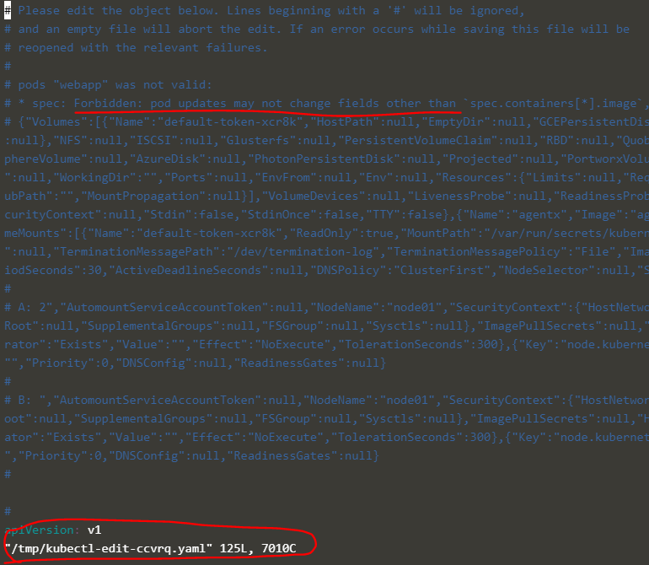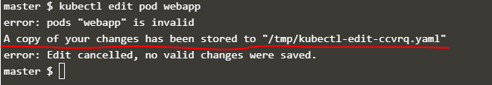

A copy of the file with your changes is saved in a temporary location as shown above.

You can then delete the existing pod by running the command:

kubectl delete pod webapp

Then create a new pod with your changes using the temporary file

kubectl create -f /tmp/kubectl-edit-ccvrq.yaml

2. The second option is to extract the pod definition in YAML format to a file using the command

kubectl get pod webapp -o yaml > my-new-pod.yaml

Then make the changes to the exported file using an editor (vi editor). Save the changes

vi my-new-pod.yaml

Then delete the existing pod

kubectl delete pod webapp

Then create a new pod with the edited file

kubectl create -f my-new-pod.yaml

#### Edit Deployments

With Deployments you can easily edit any field/property of the POD template. Since the pod template is a child of the deployment specification,  with every change the deployment will automatically delete and create a new pod with the new changes. So if you are asked to edit a property of a POD part of a deployment you may do that simply by running the command

kubectl edit deployment my-deployment

## ReplicaSet

kubectl create -f replicaset-definition.yml

kubectl get replicaset

kubectl describe replicaset myapp-replicaset

kubectl edit replicaset new-replica-set (This automatically reflected after editing)

kubectl delete replicaset myapp-replicaset

kubectl replace -f replicaset-definition.yml

kubectl scale -replicas=6 -f replicaset-definition.yml

kubectl scale rs new-replica-set --replicas=6

kubectl get replicaset new-replica-set -o yaml > replicaset-definition.yaml (Copy the replicaset definition from runtime)

## Deployment

kubectl create -f deployment-definition.yml

kubectl get all (This displays all the objects that has been created)

kubectl describe deployment

kubectl get deployments

kubectl get replicaset

kubectl get pods

## **Deployment, Rollout and Versioning**

2 types of deployment strategy- Recreate and RollingUpdate(default)

kubectl create -f deployment-definition.yml

kubectl create -f deployment-definition.yml --record (This records the change cause in history)

kubectl get deployments

kubectl describe deployment

kubectl apply -f deployment-definition.yml (This is used if we update deployment definition file and deploy)

kubectl set image deployment/myapp-deployment nginx=nginx:1.9.1

kubectl rollout status deployment/myapp-deployment

kubectl rollout history deployment/myapp-deployment

kubectl rollout undo deployment/myapp-deployment

## Service

ServiceTypes: NodePort, ClusterIP, LoadBalancer

Note: LoadBalancer is used for external service eg- frontend service.

kubectl create -f service-definition.yml

kubectl get services (It shows the cluster ip, port info)

curl http://192.162.1.2:30008 (ipaddress can be any node's ip)

## Namespace

Kubernetes supports multiple virtual clusters backed by the same physical cluster. These virtual clusters are called namespaces.

Namespaces are intended for use in environments with many users spread across multiple teams, or projects.

Namespaces provide a scope for names. Names of resources need to be unique within a namespace, but not across namespaces. Namespaces can not be nested inside one another and each Kubernetes resource can only be in one namespace.

kubectl get namespace

NAME STATUS AGE

default Active 1d

kube-system Active 1d

kube-public Active 1d

default namespace

service: db-service

mysql.connect(“db-service”)

DEV namespace

service: db-service

mysql.connect(“db-service.dev.svc.cluster.local”)

Here,

service name= db-service

namespace= dev

service= svc

domain= cluster.local

### Commands

kubectl get pods

kubectl get pods --namespace=kube-system

kubectl create -f pod-definition.yml

kubectl create -f pod-definition.yml --namespace=dev 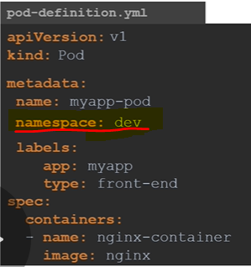

kubectl create namespace dev

kubectl create -f namespace-dev.yml

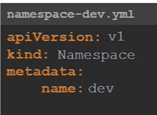

Switching between Namespaces(dev, default, prod)

kubectl get pods --namespace=dev

kubectl get pods

kubectl get pods --namespace=prod

kubectl get pods --all-namespace

**Switch to dev namespace as below**

kubectl config set-context $(kubectl config current-context) --namespace=dev

kubectl get pods (This only displays pods from dev namespace)

### Resource Quota

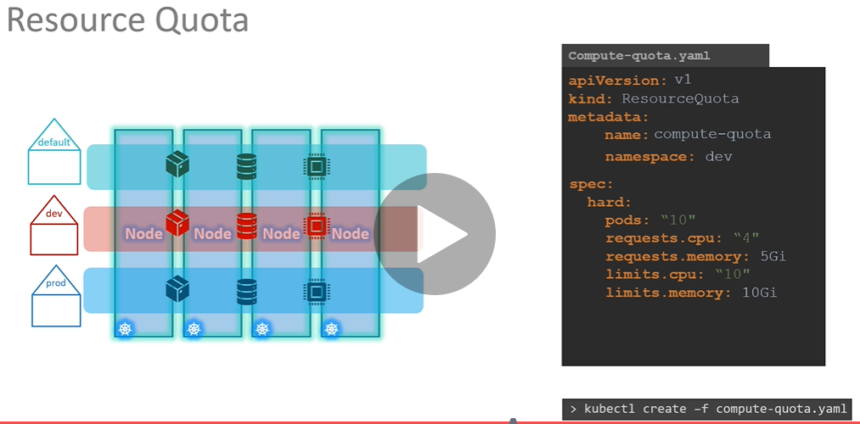

### Q&A

1)Create a POD in the 'finance' namespace.

Use the spec given on the right.

Name: redis

Image Name: redis

kubectl run --generator=run-pod/v1 redis --image=redis --namespace=finance --dry-run -o yaml (deprecated method)

kubectl run redis --image=redis --namespace=finance --dry-run=client -o yaml

kubectl run --generator=run-pod/v1 redis --image=redis --namespace=finance

kubectl get pods --namespace=finance

2)Which namespace has the 'blue' pod in it?

kubectl get pods --all-namespaces

kubectl get pods --all-namespaces | grep blue

3)What DNS name should the Blue application use to access the database 'db-service' in its own namespace - 'marketing'.

You can try it in the web application UI. Use port 3306.

(Ans) db-service

master $ kubectl get services --all-namespaces -o wide

NAMESPACE NAME TYPE CLUSTER-IP EXTERNAL-IP PORT(S) AGE SELECTOR

default kubernetes ClusterIP 10.96.0.1 <none> 443/TCP 25m <none>

dev db-service ClusterIP 10.104.236.188 <none> 3306/TCP 24m name=mysql

finance payroll-service NodePort 10.109.7.46 <none> 8080:30083/TCP 24m name=payroll

kube-system kube-dns ClusterIP 10.96.0.10 <none> 53/UDP,53/TCP,9153/TCP 25m k8s-app=kube-dns

manufacturing red-service NodePort 10.100.70.35 <none> 8080:30080/TCP 24m name=red-app

marketing blue-service NodePort 10.110.198.222 <none> 8080:30082/TCP 24m name=blue

marketing db-service NodePort 10.97.200.211 <none> 3306:32608/TCP 24m name=mysql

master $

4)What DNS name should the Blue application use to access the database 'db-service' in the 'dev' namespace

You can try it in the web application UI. Use port 3306.

(Ans)

db-service.dev.svc.cluster.local

## How To Create?

### **ReplicationController**

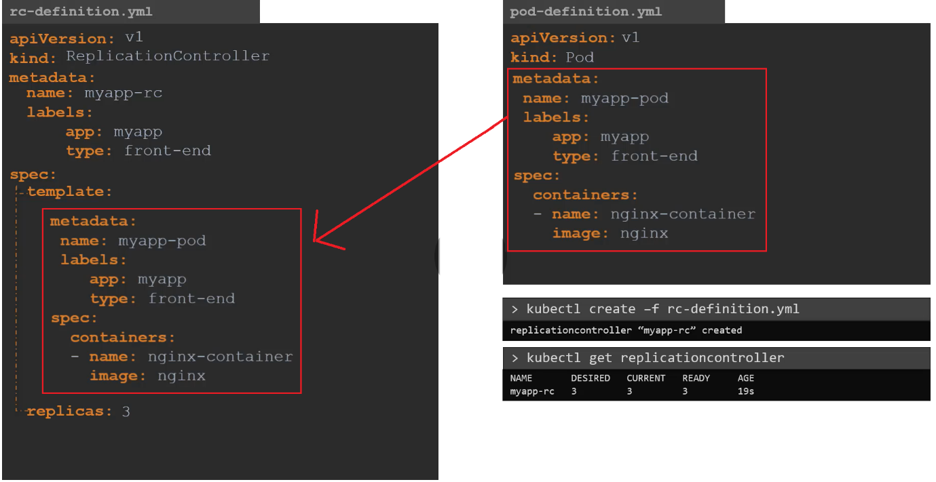

### **ReplicaSet**

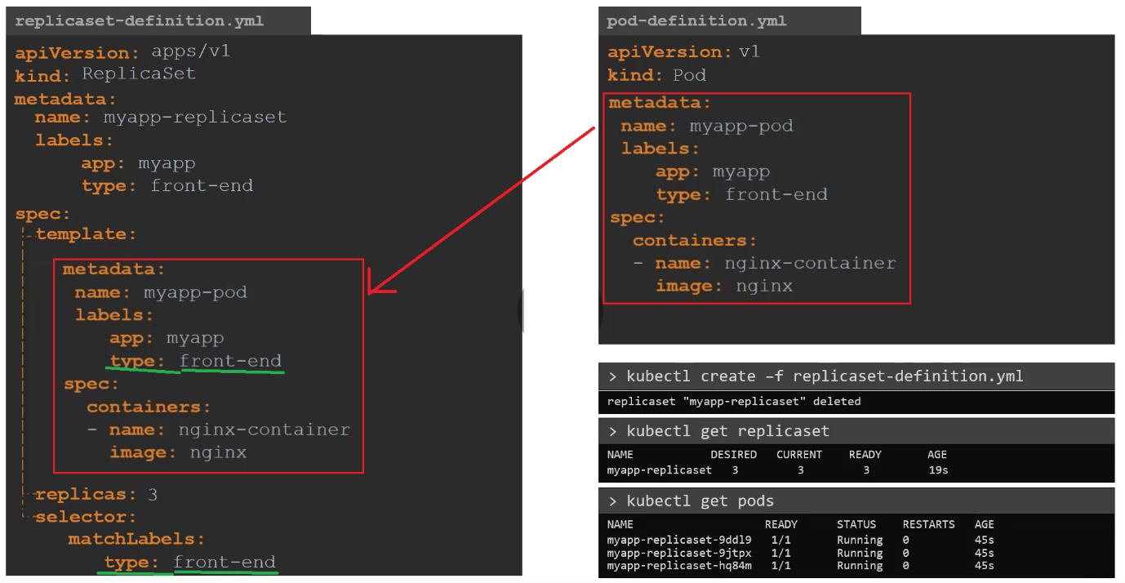

|  |  |
| --- | --- |
| ReplicationController | ReplicaSet |
| Old way | New way  Replica Set is enhance version of Replication Controller. |
| apiVersion: v1 | apiVersion: apps/v1 |
| selector is not present | selector is present |
| Replication Controller only supports equality-based selector.  Ex. environment = production | Replica Set supports the new set-based selector. This gives more flexibility.  Ex. environment in (production, qa) |
| rolling-update command is used for updating the replication controller. | rollout command is used for updating the replica set. |
|  | Replica Set Non-Template Pods acquisitions.  It is strongly recommended to make sure that the bare Pods do not have labels which match the selector of one of your ReplicaSets. |
|  | Scale Replica Sets  kubectl autoscale rs/<ReplicaSetName> —max=<ReplicaCount> |

### **Deployment**

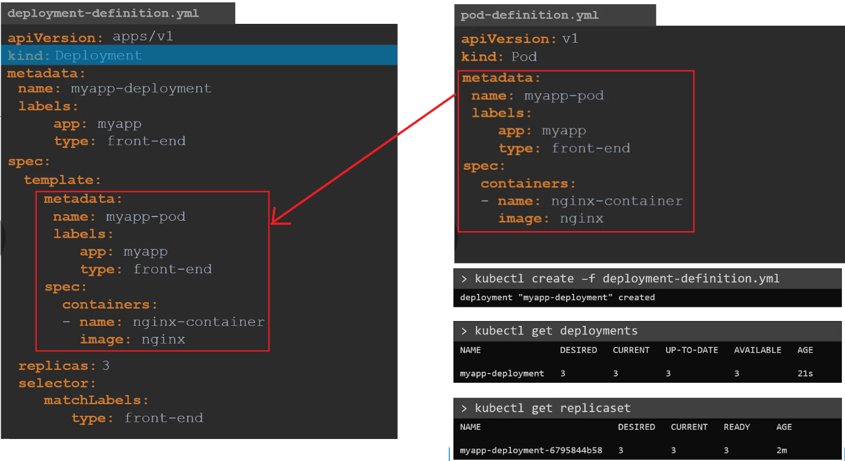

### **Service**

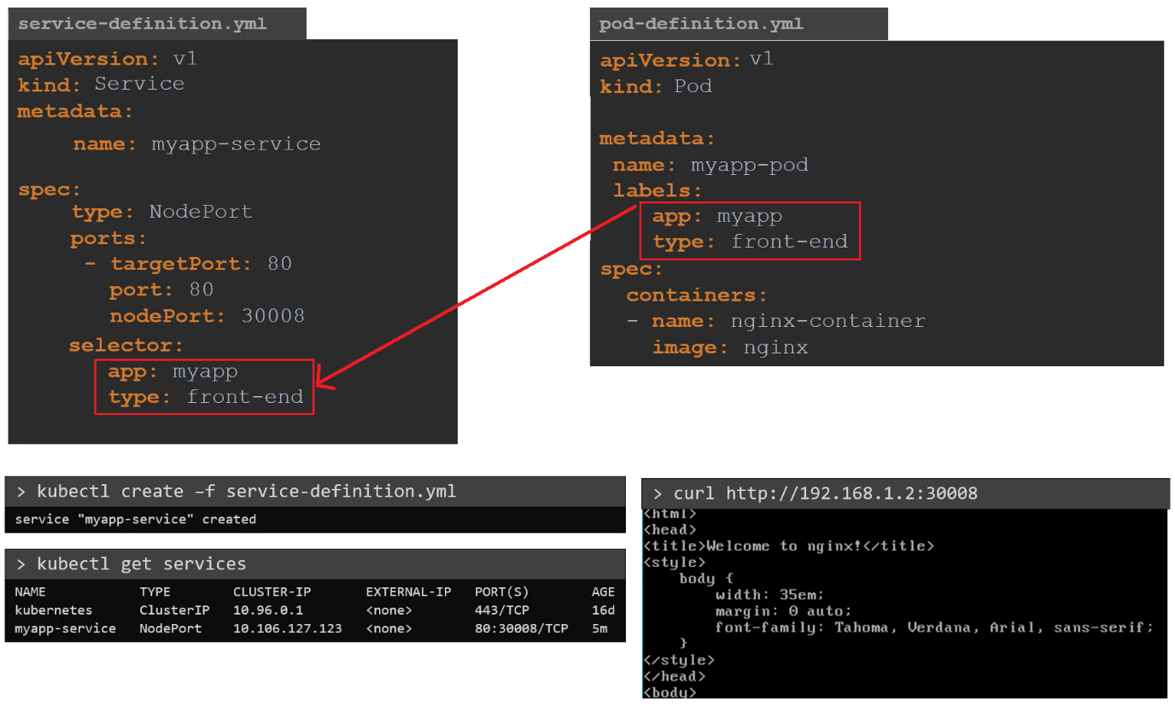

# Certification Tip:

## Kubectl autocomplete

### **BASH**

source <(kubectl completion bash) *# setup autocomplete in bash into the current shell, bash-completion package should be installed first.*

echo "source <(kubectl completion bash)" >> ~/.bashrc *# add autocomplete permanently to your bash shell.*

## Use Shortcut/Aliases

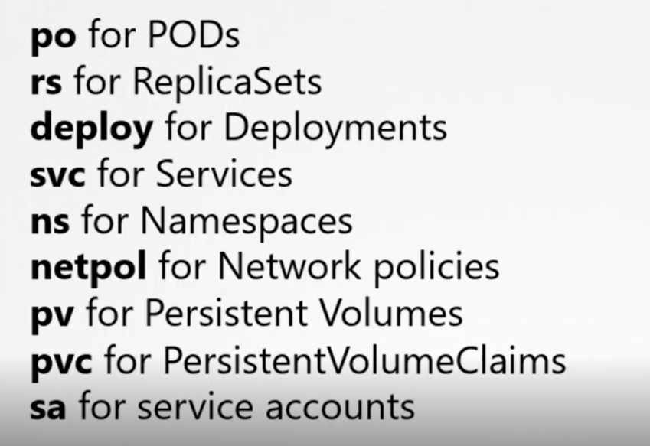

## Imperative Commands

While you would be working mostly the declarative way - using definition files, imperative commands can help in getting one time tasks done quickly, as well as generate a definition template easily. This would help save a considerable amount of time during your exams.

Before we begin, familiarize with the two options that can come in handy while working with the below commands:

--dry-run: By default as soon as the command is run, the resource will be created. If you simply want to test your command, use the --dry-run option. This will not create the resource, instead, tell you whether the resource can be created and if your command is right.

-o yaml: This will output the resource definition in YAML format on the screen.

Examples:

Deploy a pod named nginx-pod using the nginx:alpine image.(Use imperative commands only)

kubectl run --generator=run-pod/v1 nginx-pod --image=nginx:alpine --dry-run -o yaml

kubectl run --generator=run-pod/v1 nginx-pod --image=nginx:alpine

kubectl run nginx-test --image=nginx --dry-run=client -o yaml

Deploy a redis pod using the redis:alpine image with the labels set to tier=db.

Either use imperative commands to create the pod with the labels. Or

else use imperative commands to generate the pod definition file, then add the labels before creating the pod using the file.

kubectl run --generator=run-pod/v1 redis --image=redis:alpine -l tier=db --dry-run -o yaml

kubectl run --generator=run-pod/v1 redis --image=redis:alpine -l tier=db

kubectl run redis-pod --image=redis:alpine -l tier=db --dry-run=client -o yaml

Create a service redis-service to expose the redis application within the cluster on port 6379.

Use imperative commands

Service: redis-service

Port: 6379

Type: ClusterIp

Selector: tier=db

We can expose a pod as a service as below.

kubectl expose pod redis --port=6379 --name redis-service --dry-run -o yaml

kubectl expose pod redis --port=6379 --name redis-service --dry-run=client -o yaml

kubectl expose pod redis --port=6379 --name redis-service

Create a deployment named webapp using the image kodekloud/webapp-color with 3 replicas

Try to use imperative commands only. Do not create definition files.

Name: webapp

Image: kodekloud/webapp-color

Replicas: 3

Use the command

kubectl create deployment webapp --image=kodekloud/webapp-color --dry-run -o yaml

kubectl create deployment webapp --image=kodekloud/webapp-color

The scale the webapp to 3 using command

kubectl scale deployment/webapp --replicas=3

## Few more commands

$alias k=kubectl

$k get deploy

$KUBE_EDITOR=nano k get deploy

$k config set-context mycontext --namespace=mynamespace

$k explain cronjob.spec.JobTemplate --recursive (while working on the cronjob and we want to know what are all the properties comes under the CronJob)

kubectl command reference- Practice the commonly used commands

**Useful commands**

---------------

kubectl run nginx --image=nginx (deployment)

kubectl run nginx --image=nginx --restart=Never --generator=run-pod/v1 (pod)

kubectl run nginx --image=nginx --restart=OnFailure (job)

kubectl run nginx --image=nginx --restart=OnFailure --schedule="* * * * *" (cronJob)

kubectl run nginx --image=nginx --restart=Never --port=80 --namespace=myname --command --serviceaccount=mysa1 --env=HOSTNAME=local --labels=bu=finance,env=dev --requests='cpu=100m,memory=256Mi' --limits='cpu=200m,memory=512Mi' --dry-run -o yaml -- /bin/sh -c 'echo hello world'

Use this command to create a deployment:

kubectl run nginx --image=nginx

Use this command to create a service from the deployment above:

kubectl expose deployment nginx --port=80 --type=NodePort

kubectl run frontend --replicas=2 --labels=run=load-balancer-example --image=busybox --port=80

kubectl run frontend --replicas=2 --labels=run=load-balancer-example --image=busybox --port=80 --dry-run -o yaml (deployment)

kubectl expose deployment frontend --type=NodePort --name=frontend-service --port=6262 --target-port=8080 --dry-run -o yaml (service)

kubectl set serviceaccount deployment frontend myuser

kubectl create service clusterip my-cs --tcp=5678:8080 --dry-run -o yaml

Unix bash one-liners

args:["-c","while true;do date >> /var/log/app.txt;sleep 5;done"]

args[/bin/sh,-c,'i=0;while true;do echo "$i:$(date)";i=$((i+1));sleep 1;done']

args:["-c","mkdir -p collect;while true;do cat /var/data/* > /collect/data.txt;sleep 10;done"]

a=10;b=5;if[$a -le $b];then echo "a is small";else echo "b is small";fi

x=1;while[$x -le 10];do echo "welcome $x times";x=$((x+1));done

Use of GREP

kubectl describe pods| grep --context=10 annotations

kubectl describe pods| grep --context=10 Events;

## Formatting Output with kubectl

The default output format for all **kubectl** commands is the human-readable plain-text format.

The -o flag allows us to output the details in several different formats.

**kubectl [command] [TYPE] [NAME] -o <output_format>**

Here are some of the commonly used formats:

1. -o jsonOutput a JSON formatted API object.
2. -o namePrint only the resource name and nothing else.
3. -o wideOutput in the plain-text format with any additional information.
4. -o yamlOutput a YAML formatted API object.

Here are some useful examples:

* **Output with JSON format:**

1. master $ kubectl create namespace test-123 --dry-run -o json
2. {
3. "kind": "Namespace",
4. "apiVersion": "v1",
5. "metadata": {
6. "name": "test-123",
7. "creationTimestamp": null
8. },
9. "spec": {},
10. "status": {}
11. }
12. master $

* **Output with YAML format:**

1. master $ kubectl create namespace test-123 --dry-run -o yaml
2. apiVersion: v1
3. kind: Namespace
4. metadata:
5. creationTimestamp: null
6. name: test-123
7. spec: {}
8. status: {}

* **Output with wide (additional details):**

Probably the most common format used to print additional details about the object:

1. master $ kubectl get pods -o wide
2. NAME      READY   STATUS    RESTARTS   AGE     IP          NODE     NOMINATED NODE   READINESS GATES
3. busybox   1/1     Running   0          3m39s   10.36.0.2   node01   <none>           <none>
4. ningx     1/1     Running   0          7m32s   10.44.0.1   node03   <none>           <none>
5. redis     1/1     Running   0          3m59s   10.36.0.1   node01   <none>           <none>
6. master $

For more details, refer:

[**https://kubernetes.io/docs/reference/kubectl/overview/**](https://kubernetes.io/docs/reference/kubectl/overview/)

[**https://kubernetes.io/docs/reference/kubectl/cheatsheet**](https://kubernetes.io/docs/reference/kubectl/cheatsheet)**/**

## Certification Tips - Student Tips

Make sure you check out these tips and tricks from other students who have cleared the exam:

<https://www.linkedin.com/pulse/my-ckad-exam-experience-atharva-chauthaiwale/>

<https://medium.com/@harioverhere/ckad-certified-kubernetes-application-developer-my-journey-3afb0901014>

<https://github.com/lucassha/CKAD-resources>

# Configuration

### Commands and Arguments

Command and Arguments in a Kubernetes POD.

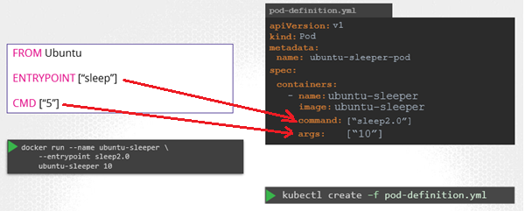

So to summarize, there are two fields that correspond to two instructions in the Dockerfile. The command overrides the entrypoint instruction and the args field overrides the command instruction in the Dockerfile. Remember the command field does not override the CMD instruction in the Dockerfile.

### ENV Variables in Kubernetes

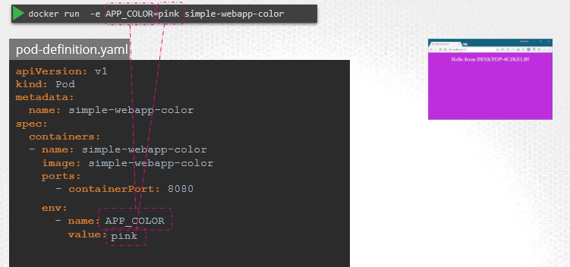

Let us now see how to pass in an environment variable in Kubernetes. Given a pod definition file, which uses the same image as the docker command. To set an environment variable, use the ENV property. ENV is an array. So every item under the env property starts with a dash, indicating an item in the array. Each item has a name and a value property. The name is the name of the environment variable made available within the container and the value is its value.

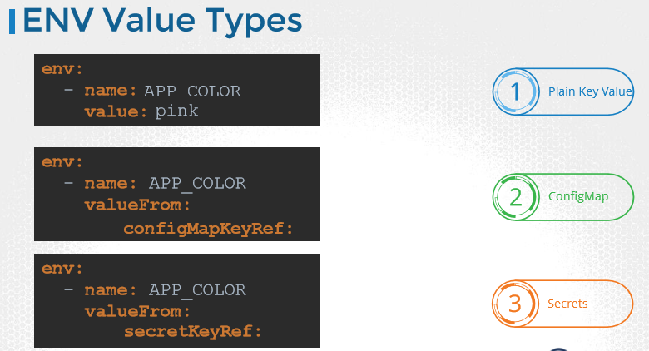

### ConfigMaps

ConfigMaps are used to pass configurations data in the form of key-value pairs in kubernetes.

When a POD is created inject the ConfigMaps so that key-value pairs are available as environment variables for the app which are hosted inside the POD.

[Pods](https://kubernetes.io/docs/concepts/workloads/pods/pod-overview/) can consume ConfigMaps as environment variables, command-line arguments, or as configuration files in a [volume](https://kubernetes.io/docs/concepts/storage/volumes/).

#### Create ConfigMaps

#### Imperative Way

kubectl create configmap <config-name> --from-literal=<key>=<value>

kubectl create configmap app-config --from-literal=APP_COLOR=blue --from-literal=APP_MODE=prod

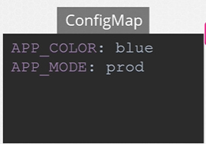

#### Declarative Way

kubectl create configmap <config-name> --from-file=<path-to-file>

kubectl create configmap <config-name> --from-file=app-config.properties

**config-map.yaml**

apiVersion: v1

kind: ConfigMap

metadata:

name: app-config

data:

APP_COLOR: blue

APP_MODE: prod

kubectl create -f config-map.yaml

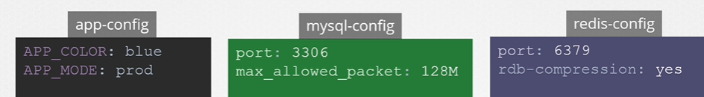

#### Commands:

View ConfigMaps

kubectl get configmaps

kubectl describe configmaps

#### ConfigMap in POD

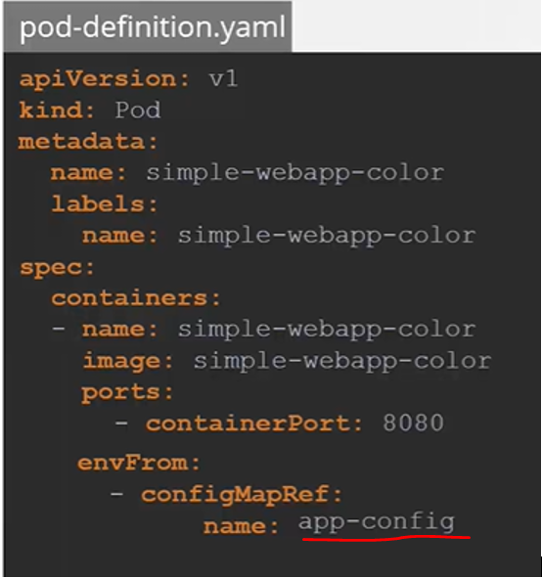

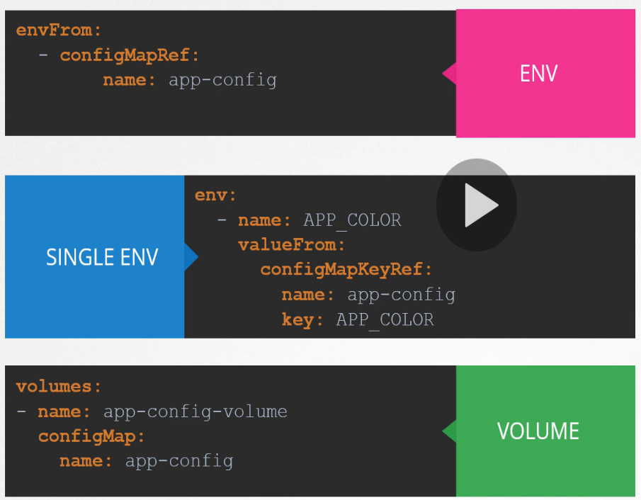

### Secrets

Secrets are used to store sensitive information, like passwords or keys. They are similar to configMaps, except that they are stored in an encoded or hashed format. As with configMaps, there are two steps involved in working with Secrets. First, create the secret and second inject it into Pod.

There are two ways of creating a secret. The imperative way - without using a Secret definition file and the Declarative way by using a Secret Definition file.

With the Imperative method you can directly specify the key value pairs in the command line itself. To create a secret of the given values, run the

kubectl create secret generic command.

#### Create Secrets

##### **Imperative Way**

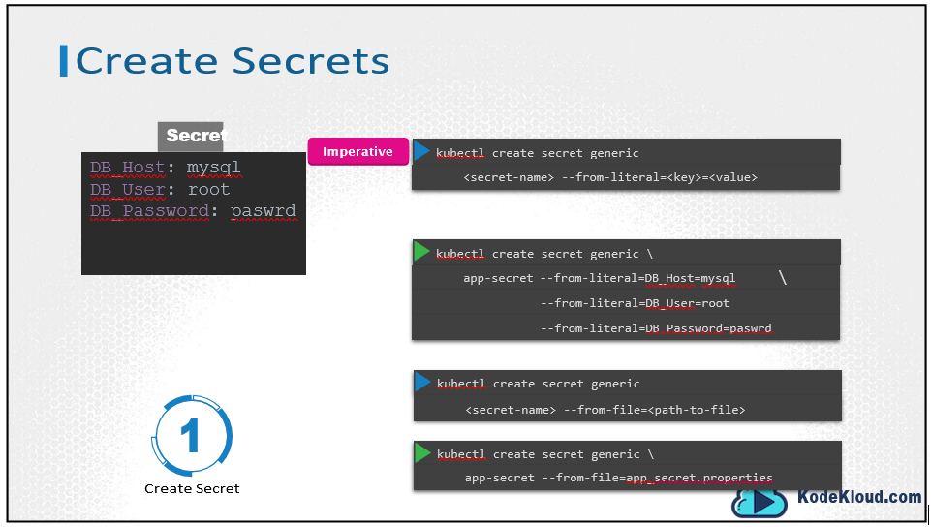

kubectl create secret generic

<secret-name> --from-literal=<key>=<value>

kubectl create secret generic \

app-secret --from-literal=DB_Host=mysql \

--from-literal=DB_User=root

--from-literal=DB_Password=paswrd

kubectl create secret generic

<secret-name> --from-file=<path-to-file>

kubectl create secret generic \

app-secret --from-file=app_secret.properties

##### **Declarative Way**

**Secret-data.yaml**

apiVersion: v1

kind: Secret

metadata:

name: app-secret

data:

DB_Host: bXlzcWw=

DB_User: cm9vdA==

DB_Password: cGFzd3Jk

kubectl create –f secret-data.yaml

However, one thing we discussed about secrets was that they are used to store sensitive data and are stored in an encoded format. Here we have specified the data in plain text, which is not very safe. So, while creating a secret with the declarative approach, you must specify the secret values in a hashed format.

#### Encode Secrets

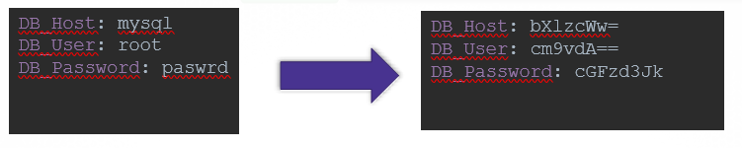

echo –n ‘mysql’ | base64

bXlzcWw=

echo –n ‘root’ | base64

cm9vdA==

echo –n ‘paswrd’ | base64

cGFzd3Jk

#### View Secrets

kubectl get secrets

kubectl describe secrets

kubectl get secret app-secret –o yaml

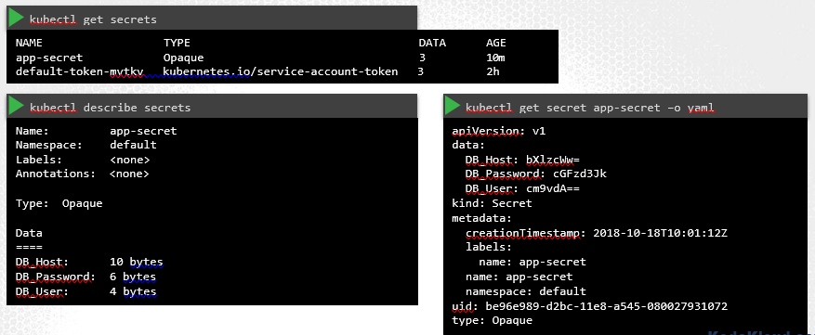

#### Decode Secrets

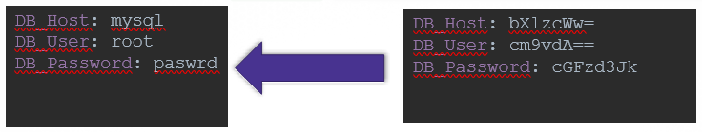

How do you decode the hashed values? Use the same base64 command you used in linux to encode it, but this time add a decode option to it.

echo –n ‘bXlzcWw=’ | base64 --decode

mysql

echo –n ‘cm9vdA==’ | base64 --decode

root

echo –n ‘cGFzd3Jk’ | base64 --decode

paswrd

#### Secrets in Pods

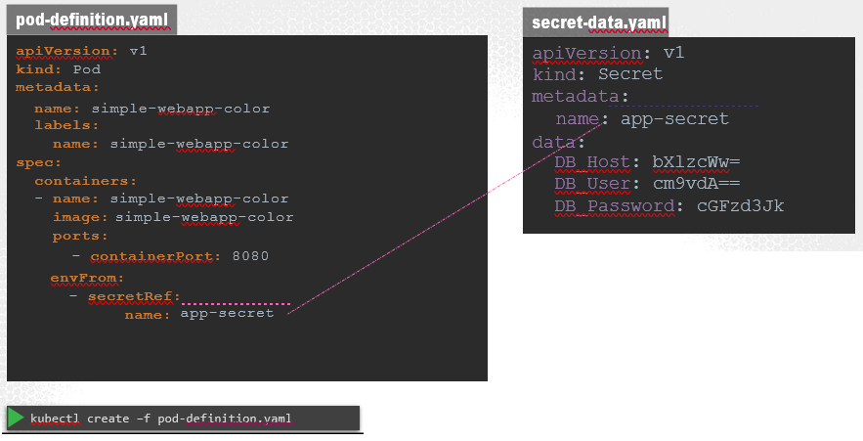

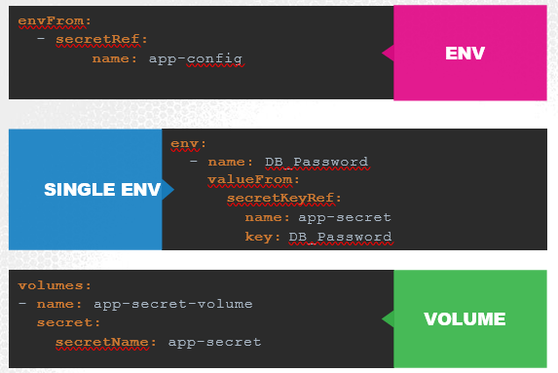

What we just saw was injecting secrets as environment variables into the PODs. There are other ways to inject secret into PODs. You can inject as single environment variables or inject the whole secret as files in a volume.

#### Secrets in Pods as Volumes

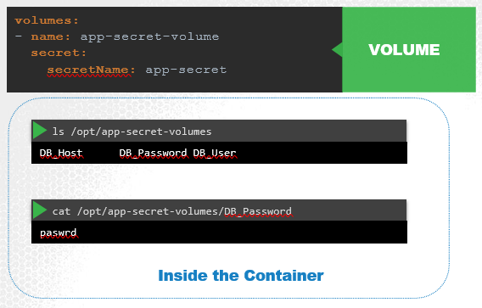

#### Q&A

**(1)How many Secrets exist on the system?**

in the current(default) namespace

kubectl get secrets

**(2)How many secrets are defined in the 'default-token' secret?**

kubectl get secrets (Look at the DATA field)

kubectl describe secret default-token-qqwj5

**(3)The reason the application is failed is because we have not created the secrets yet. Create a new Secret named 'db-secret' with the data given(on the right).**

**You may follow any one of the methods discussed in lecture to create the secret.**

Secret Name: db-secret

Secret 1: DB_Host=sql01

Secret 2: DB_User=root

Secret 3: DB_Password=password123

kubectl create secret generic db-secret --from-literal=DB_Host=sql01 --from-literal=DB_User=root --from-literal=DB_Password=password123

**(5)If pod is not properly configured with secret values, do as below**

- kubectl edit pod webapp-pod

-It will generate one pod definition file in some directory.

- kubectl delete pod webapp-pod

-kubectl create -f <path-to-pod-definition-file>

If you were to mount the secret as a volume in the Pod, each attribute in the secret is created as a file with the value of the secret as its content. In this case, since we have 3 attributes in our secret, 3 files are created. And if we look at the contents of the DB_password file, we see the password inside it.

#### A quick note about Secrets!

Remember that secrets encode data in base64 format. Anyone with the base64 encoded secret can easily decode it. As such the secrets can be considered as not very safe.

The concept of safety of the Secrets is a bit confusing in Kubernetes. The [kubernetes documentation](https://kubernetes.io/docs/concepts/configuration/secret) page and a lot of blogs out there refer to secrets as a "safer option" to store sensitive data. They are safer than storing in plain text as they reduce the risk of accidentally exposing passwords and other sensitive data. In my opinion it's not the secret itself that is safe, it is the practices around it.

Secrets are not encrypted, so it is not safer in that sense. However, some best practices around using secrets make it safer. As in best practices like:

* Not checking-in secret object definition files to source code repositories.
* [Enabling Encryption at Rest](https://kubernetes.io/docs/tasks/administer-cluster/encrypt-data/)for Secrets so they are stored encrypted in ETCD.

Also the way kubernetes handles secrets. Such as:

* A secret is only sent to a node if a pod on that node requires it.
* Kubelet stores the secret into a tmpfs so that the secret is not written to disk storage.
* Once the Pod that depends on the secret is deleted, kubelet will delete its local copy of the secret data as well.

Read about the [protections](https://kubernetes.io/docs/concepts/configuration/secret/#protections)and [risks](https://kubernetes.io/docs/concepts/configuration/secret/#risks) of using secrets [here](https://kubernetes.io/docs/concepts/configuration/secret/#risks)

Having said that, there are other better ways of handling sensitive data like passwords in Kubernetes, such as using tools like Helm Secrets, [HashiCorp Vault](https://www.vaultproject.io/). I hope to make a lecture on these in the future.

### Security in Docker

Unlike virtual machines containers are not completely isolated from their host. Containers and the hosts share the same kernel. Containers are isolated using namespaces in Linux.

Docker container can see its own processes only, cannot see anything outside of it or in any other namespace.

For the docker host, all processes of its own as well as those in the child namespaces are visible as just another process in the system. Docker isolates containers within a system. So that’s process isolation.

#### Security - Users

The docker host has a set of users, a root user as well as a number of non-root users. By default docker runs processes within containers as the root user. Now if you do not want the process within the container to run as the root user, you may set the user using the user option with the docker run command and specify the new user ID.

Another way to enforce user security is to have this defined in the Docker image itself at the time of creation. For example, we will use the default ubuntu image and set the user ID to 1000 using the USER instruction. Then build the custom image. We can now run this image using without specifying the user ID and the process will be run with the user id 1000.

**Dockerfile**

FROM ubuntu

USER 1001

-------

docker build –t my-ubuntu-image .

docker run my-ubuntu-image sleep 3600

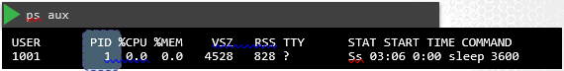

Docker implements a set of security features that limits the abilities of the root user within the container. So the root user within the container isn’t really like the root user on the host.

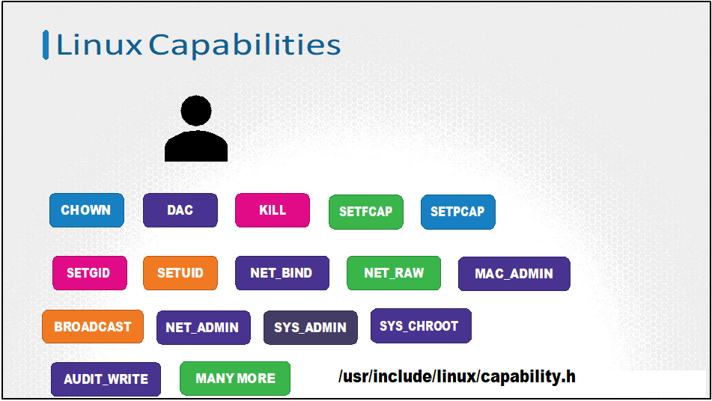

The **“root”** has unrestricted access to the system. From modifying files and permissions on files, Access Control, creating or killing processes, setting group id or user ID, performing network related operations such as binding to network ports, broadcasting on a network, controlling network ports; system related operations like rebooting the host, manipulating system clock and many more. All of these are the different capabilities on a Linux system and you can see a full list at this location. You can now control and limit what capabilities are made available to a process.

By default, Docker runs a container with a limited set of capabilities. And so the processes running within the container do not have the privileges to say, reboot the host or perform operations that can disrupt the host or other containers running on the same host. In case you wish to override this behavior and enable all privileges to the container use the privileged flag.

docker run --cap-add MAC_ADMIN ubuntu (Allow MAC_ADMIN priviledge)

docker run --cap-drop KILL ubuntu (Allow KILL priviledge)

docker run --privileged ubuntu (Allow All priviledge)

### Kubernetes Security Contexts

When you run a Docker Container you have the option to define a set of security standards, such as the ID of the user used to run the container, the Linux capabilities that can be added or removed from the container etc.

These can be configured in Kubernetes as well.

Kubernetes containers are encapsulated in PODs. You may choose to configure the security settings at a Container level or at POD level.

If you configure it at a POD level, the settings will carry over to all the containers within the POD. If you configure it at both the POD and the Container, the settings on the container will override the settings on the POD.

|  |  |
| --- | --- |
| Security at POD Level | Security at Container Level |
|  |  |

To add capabilities use the OS capabilities option and specify a list of capabilities to add to the POD.

Capabilities are only supported at the container level and not at the POD level.

#### Q&A

**(1)What is the user used to execute the sleep process within the 'ubuntu-sleeper' pod?**

**in the current(default) namespace**

kubectl exec ubuntu-sleeper -- whoami

**(2)Try to run the below command in the pod 'ubuntu-sleeper' to set the date. Are you allowed to set date on the POD?**

**date -s '19 APR 2012 11:14:00'**

master $ kubectl exec -it ubuntu-sleeper -- date -s '19 APR 2012 11:14:00'

date: cannot set date: Operation not permitted

Thu Apr 19 11:14:00 UTC 2012

command terminated with exit code 1

### Service Accounts

The concept of service accounts is linked to other security related concepts in kubernetes such as Authentication, Authorization, Role based access controls etc.

There are two types of accounts in Kubernetes.

User Account-

* Used by humans (Admin, User)
* Administrator accessing the cluster to perform administrative tasks, a developer accessing the cluster to deploy applications etc.

Service Account-

* Used by machines
* Monitoring application like Prometheus uses a service account to poll the kubernetes API for performance metrics.
* An automated build tool like Jenkins uses service accounts to deploy applications on the kubernetes cluster.

To create a serviceaccount

kubectl create serviceaccount <service-account-name>

To view/list all the service accounts

kubectl get serviceaccount

To view the serviceaccount details

kubectl describe serviceaccount <service-account-name>

When a service account is created, it first creates the **service account object** and then generates a **token** for the service account. It then creates a **secret object** and stores that token inside the secret object. The secret object is then linked to the service account. To view the token, view the secret object by running the command kubectl describe secret.

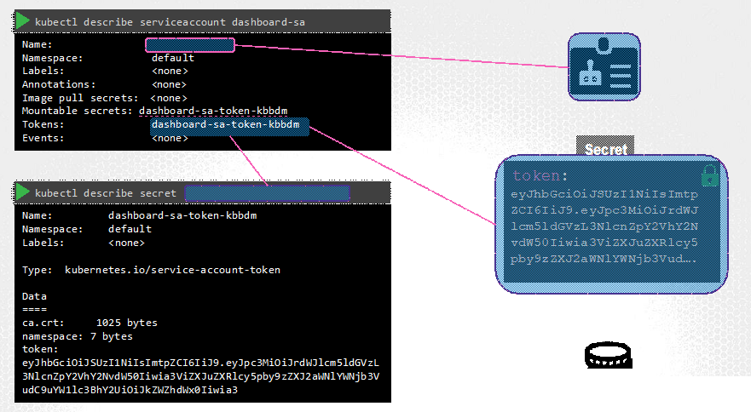

kubectl describe serviceaccount <service-account-name>

kubectl describe secret <token-name>

This token can then be used as an authentication bearer token while making a rest call to the kubernetes API. For example, in this simple example using curl you could provide the bearer token as an Authorization header while making a rest call to the kubernetes API.

In case of my custom dashboard application, copy and paste the token into the tokens field to authenticate the dashboard application.

curl https://192.168.56.70:6443/api –insecure

--header “Authorization: Bearer eyJhbG… ”

So, that’s how you create a new service account and use it. You can create a service account, assign the right permissions using Role based access control mechanisms (which is out of scope for this course) and export your service account tokens and use it to configure your third party application to authenticate to the kubernetes API. But what if your third party application is hosted on the kubernetes cluster itself. For example, we can have our custom-kubernetes-dashboard or the Prometheus application used to monitor kubernetes, deployed on the kubernetes cluster itself.

In that case, this whole process of exporting the service account token and configuring the third party application to use it can be made simple by automatically mounting the service token secret as a volume inside the POD hosting the third party application. That way the token to access the kubernetes API is already placed inside the POD and can be easily read by the application.

For every namespace in kubernetes a service account named default is automatically created. Whenever a POD is created the default service account and its token are automatically mounted to that POD as a volume mount.

**kubectl describe <service-account-name>**

**kubectl exec -it <service-account-name> ls /var/run/secrets/kubernetes.io/serviceaccount**

**kubectl exec -it <service-account-name> cat /var/run/secrets/kubernetes.io/serviceaccount/token**

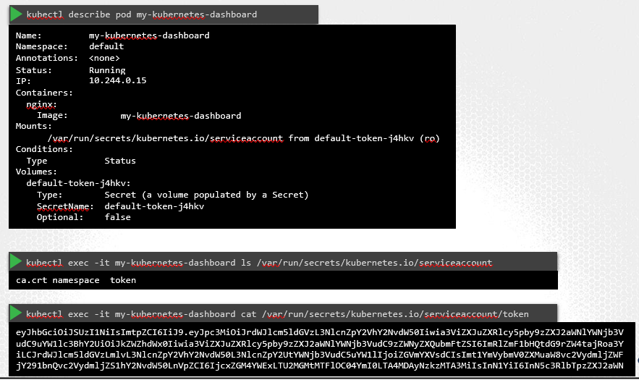

Specifying serviceaccount in POD definition

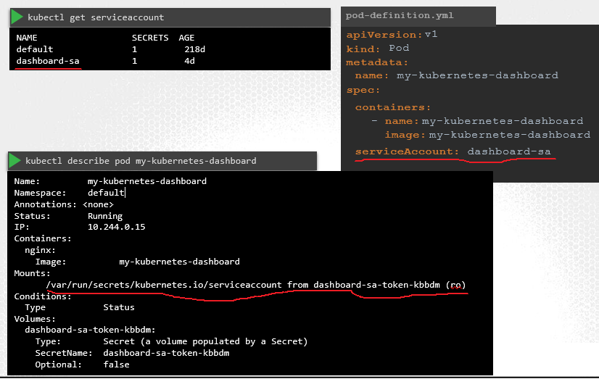

If you’d like to use a different serviceAccount, such as the ones we just created, modify the pod definition file to include a serviceAccount field and specify the name of the new service account. Remember, you cannot edit the service account of an existing pod, so you must delete and re-create the pod. However, in case of a deployment, you will be able to edit the serviceAccount, as any changes to the pod definition will automatically trigger a new roll-out for the deployment. So the deployment will take care of deleting and re-creating new pods with the right service account. When you look at the pod details now, you see that the new service account is being used.

kubernetes automatically mounts the default service account if you haven’t explicitly specified any. You may choose not to mount a service account automatically by setting the automountServiceAccountToken field to false in the POD spec section.

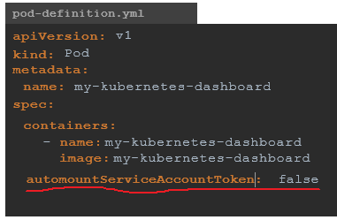

#### Q&A

**(1)How many Service Accounts exist in the default namespace?**

kubectl get serviceaccounts

**(2)What is the secret token used by the default service account?**

kubectl get serviceaccounts

kubectl describe serviceaccount default

**(3)At what location is the ServiceAccount credentials available within the pod?**

**/var/run/secrets**

**Enter the access token in the UI of the dashboard application. Click 'Load Dashboard' button to load Dashboard**

**Retrieve the Authorization token for the newly created service account , copy it and paste it into the 'token' field of the UI**

kubectl get serviceaccounts

kubectl describe serviceaccount <service-account-name>

kubectl describe secret <token-name>

### Resource Requirements

Each node has a set of CPU, Memory and Disk resources available. Every POD consumes a set of resources. Whenever a POD is placed on a Node, it consumes resources available to that node.

It is the kubernetes scheduler that decides which Node a POD goes to. The scheduler takes into consideration, the amount of resources required by a POD and those available on the Nodes.

If the node has no sufficient resources, the scheduler avoids placing the POD on that

node….. Instead places the POD on one were sufficient resources are available.

If there is no sufficient resources available on any of the nodes, Kubernetes holds back scheduling the POD, and you will see the POD in a pending state. If you look at the events, you will see the reason – insufficient cpu.

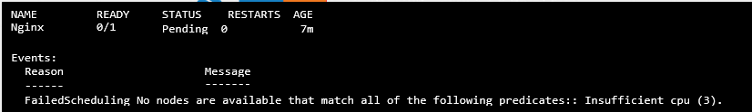

#### Resource Requests

By default, kubernetes assumes that a POD or a container within a POD requires .5 CPU & 256 Mebibyte of memory. You can modify these values, by specifying them in your POD or deployment definition files.

#### Resource Limits

If you don’t like the default limits, you can change them by adding a limits section under the resources section in your pod definition. Specify new limits for memory and cpu. When the pod is created, kubernetes sets new limits for the container. Remember that the limits and requests are set for each container.

So what happens when a pod tries to exceed resources beyond its specified limit. In case of the CPU, kubernetes throttles the CPU so that it does not go beyond the specified limit. A container cannot use more CPU resources than its limit. However, this is not the case with memory. A container CAN use more memory resources that its limit. So if a pod tries to consume more memory than its limit constantly, the POD will be terminated.

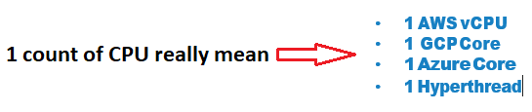

#### Specify resource request and limits in pod-definition file

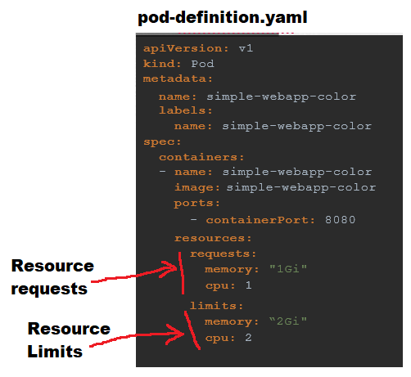

#### Note on default resource requirements and limits

In the previous lecture, I said - "When a pod is created the containers are assigned a default CPU request of .5 and memory of 256Mi". For the POD to pick up those defaults you must have first set those as default values for request and limit by creating a LimitRange in that namespace.

1. apiVersion: v1
2. kind: LimitRange
3. metadata:
4. name: mem-limit-range
5. spec:
6. limits:
7. - default:
8. memory: 512Mi
9. defaultRequest:
10. memory: 256Mi
11. type: Container

<https://kubernetes.io/docs/tasks/administer-cluster/manage-resources/memory-default-namespace/>

1. apiVersion: v1
2. kind: LimitRange
3. metadata:
4. name: cpu-limit-range
5. spec:
6. limits:
7. - default:
8. cpu: 1
9. defaultRequest:
10. cpu: 0.5
11. type: Container

<https://kubernetes.io/docs/tasks/administer-cluster/manage-resources/cpu-default-namespace/>

**References:**

<https://kubernetes.io/docs/tasks/configure-pod-container/assign-memory-resource>

### Taints and Tolerations

**Taints** are applied to node, and allow a node to repel a set of pods.

**Tolerations** are applied to pods, and allow (but do not require) the pods to schedule onto nodes with matching taints.

Taints and tolerations work together to ensure that pods are not scheduled onto inappropriate nodes. One or more taints are applied to a node; this marks that the node should not accept any pods that do not tolerate the taints.

**Taints – Node**

kubectl taint nodes <node-name> key=value:<taint-effect>

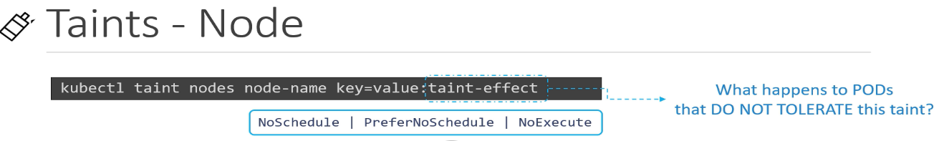

**NoSchedule**: This means that no pod will be able to schedule onto particular tainted node unless it has a matching toleration.

**PreferNoSchedule**: This is a “preference” or “soft” version of NoSchedule – the system will try to avoid placing a pod that does not tolerate the taint on the node, but it is not required.

**NoExecute**: If NoExecute option is added to a node, then any pods that do not tolerate the taint will be evicted immediately, and pods that do tolerate the taint will never be evicted.

**Tolerations – PODs**

kubectl taint nodes node1 app=blue: NoSchedule

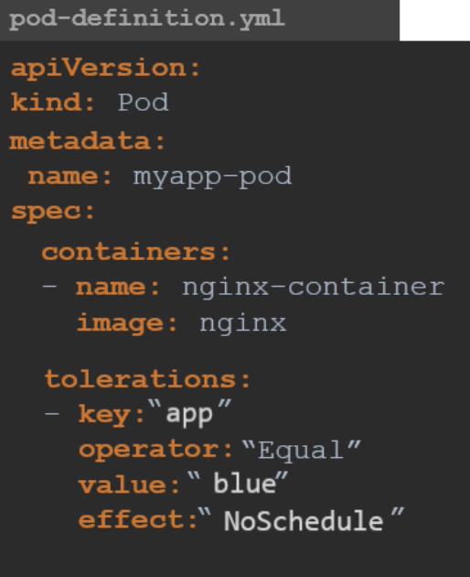

When the cluster is setup initially, a taint is automatically applied to master node.

kubectl describe node kubemaster | grep Taint



#### Q&A

**(1)Do any taints exist on node01?**

kubectl describe node node01

kubectl describe node node01 | grep –i taint

**(2)Create a taint on node01 with key of 'spray', value of 'mortein' and effect of 'NoSchedule'**

kubectl taint nodes node01 spray=mortein:NoSchedule

**(3)Create a new pod with the NGINX image, and Pod name as 'mosquito'**

kubectl run --generator=run-pod/v1 mosquito --image=nginx

**(4)Remove the taint on master, which currently has the taint effect of NoSchedule**

kubectl taint nodes master node-role.kubernetes.io/master:NoSchedule-

### Node Selectors

For the pod to be eligible to run on a node, the node must have each of the indicated key-value pairs as labels (it can have additional labels as well). The most common usage is one key-value pair.

kubectl label nodes <node-name> <label-key>=<label-value>

kubectl label nodes node1 size=Large

**pod-definition.yaml**

apiVersion: v1

kind: Pod

metadata:

name: nginx

labels:

env: test

spec:

containers:

- name: nginx

image: nginx

imagePullPolicy: IfNotPresent

nodeSelector:

size: Large

### Node Affinity

Node affinity is conceptually similar to nodeSelector – it allows you to constrain which nodes your pod is eligible to be scheduled on, based on labels on the node.

There are currently two types of node affinity,

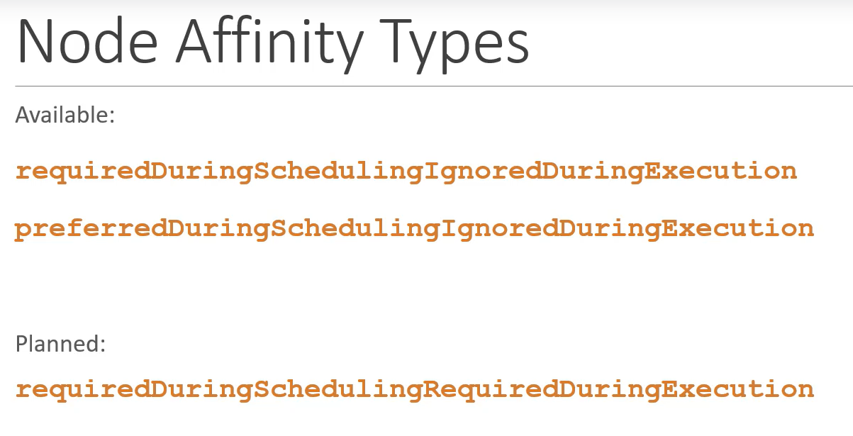

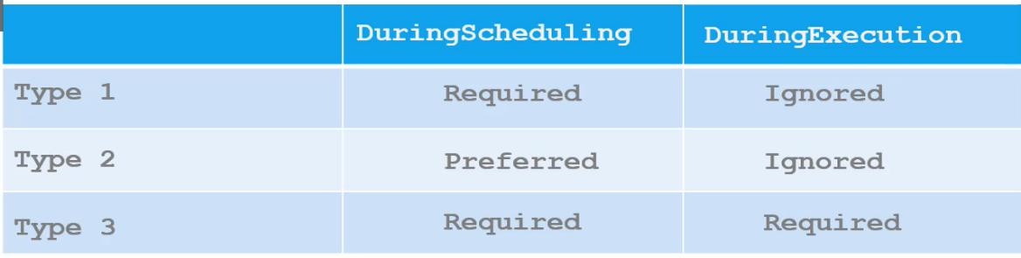

You can think of them as “hard” and “soft” respectively

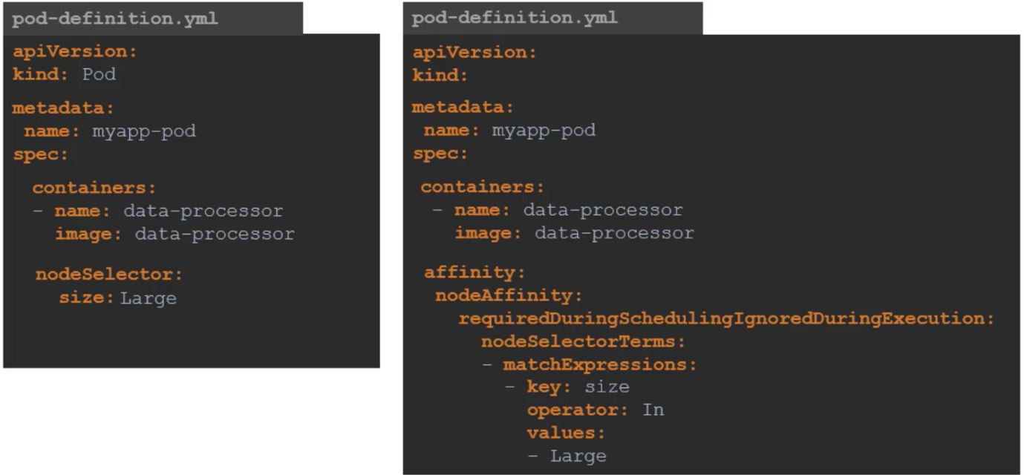

Other Expressions

|  |  |
| --- | --- |
|  |  |

By using both Taints/Tolerations and Node Affinity together we can completely dedicate nodes to specific pods.

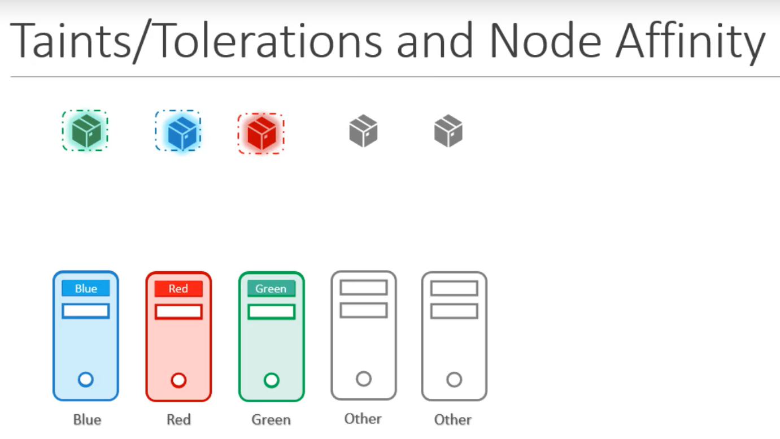

#### Q&A

**(1)How many Labels exist on node node01?**

kubectl describe node node01

**(2)Set Node Affinity to the deployment to place the PODs on node01 only**

Name: blue

Replicas: 6

Image: nginx

NodeAffinity: requiredDuringSchedulingIgnoredDuringExecution

Key: color

values: blue

affinity:

nodeAffinity:

requiredDuringSchedulingIgnoredDuringExecution:

nodeSelectorTerms:

- matchExpressions:

- key: color

operator: In

values:

- blue

# Multi-Container PODs

The idea of decoupling a large monolithic application into …subcomponents known as microservices enables us to develop and deploy a set of independent, small and reusable code. This, architecture then helps us scale up.., down as well as modify each service as required, as opposed to modifying the entire application.

However, at times you may need two services to work together. Such as a web server and a logging service. You need one agent per web server instance paired together …You don’t want to merge and bloat the code of the two services, as each of them target different features, and you’d still like them to be developed and deployed separately. You only need the two functionality to work together. You need one agent per web

server instance paired together …that can scale up …and down together. And that is why you have multi-container PODs….that share the same lifecycle – which means they are created together and destroyed together. They share the same network space, which means they can refer to each other as localhost. And they have access to the same storage volumes. This way, you do not have to establish, volume sharing or services between the PODs to enable communication between them.

To create a multi-container pod, add the new container information to the pod- definition file. Remember, the containers section under the spec section in a pod definition file is an array and the reason it is an array is to allow multiple containers in a single POD. In this case we add a new container named log-agent to our existing pod.

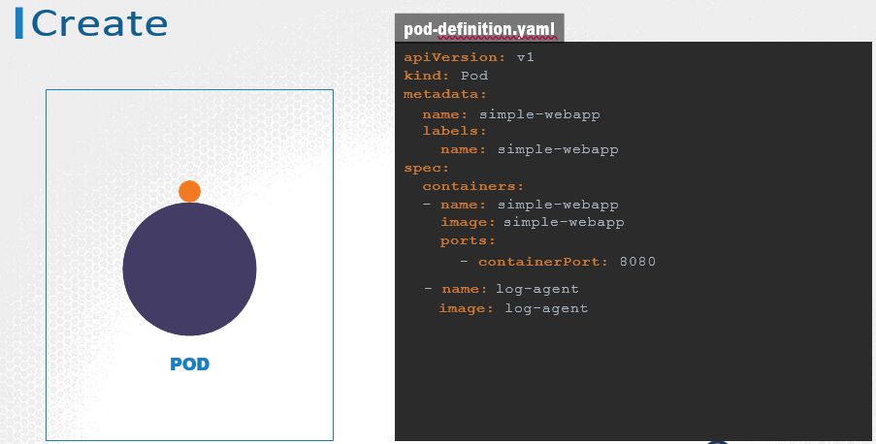

There are 3 common patterns, when it comes to designing multi-container PODs.

SIDECAR

ADAPTER

AMBASSADOR

**SIDECAR**

A good example of a side car pattern is deploying a logging agent alongside a web server to collect logs and forward them to a central log server.

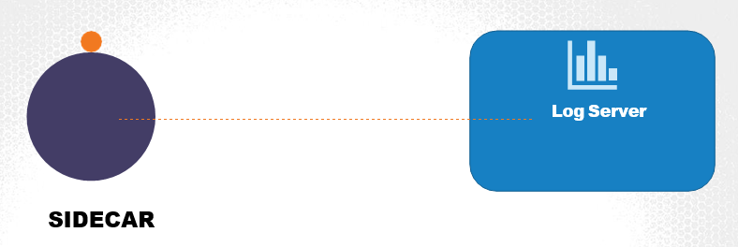

**ADAPTER**

If we have multiple applications generating logs in different formats. It would be hard to process the various formats on the central logging server. So, before sending the logs to the central server, we would like to convert the logs to a common format. For this we deploy an adapter container. The adapter container processes the logs, before sending it to the central server.



0

KodeKloud.com

ADAPTER

12-JULY-2018 16:05:49 "GET /index3.html" 20

GET 1531411549 "/index3.html" 200

12/JUL/2018:16:05:49 -0800 "GET /index2.html" 200 12-JULY-2018 16:05:49 "GET /index2.html" 20

12-JULY-2018 16:05:49 "GET /index1.html" 2

12-JULY-2018 16:05:49 "GET /index1.html" 200

Design Patterns

**AMBASSADOR**

Your application communicates to different database instances at different stages of development. A local database for development, one for testing and another for production. You must ensure to modify this connectivity depending on the environment you are deploying your application to.

You may choose to outsource such logic to a separate container within your POD, so that your application can always refer to a database at localhost, and the new container, will proxy that request to the right database. This is known as an ambassador container.

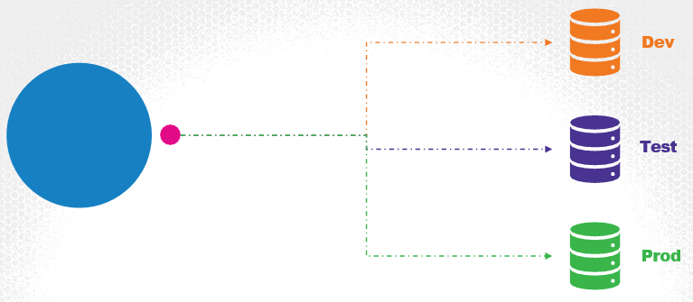

When it comes to implementing all the patterns using a pod-definition file, it is always the same. You simply have multiple containers within the pod definition file.

## Q&A

**(1)The 'app'lication outputs logs to the file /log/app.log. View the logs and try to identify the user having issues with Login.**

**Inspect the log file inside the pod**

kubectl exec -it app --namespace=elastic-stack cat /log/app.log

# Observability

### Readiness Probes

In Pod Lifecycle, POD has a pod status and some conditions.

#### POD Status

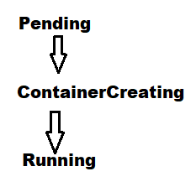

Pending:

When a POD is first created, it is in a Pending state. This is when the Scheduler tries to figure out where to place the POD. If the scheduler cannot find a node to place the POD, it remains in a Pending state. To find out why it’s stuck in a pending state, run below command

kubectl describe pod

ContainerCreating:

Once the POD is scheduled, it goes into a ContainerCreating status, where the images required for the application are pulled and the container starts.

Running:

Once all the containers in a POD starts, it goes into a running state, were it continues to be until the program completes successfully or is terminated.

However, at times you may want additional information.

#### POD Conditions

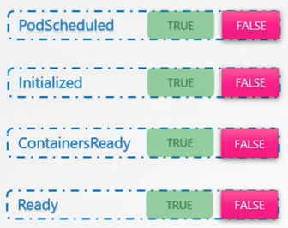

Conditions compliment POD status. It is an array of true or false values that tell us the state of a POD.

* When a POD is scheduled on a Node, the PodScheduled condition is set to True.
* When the POD is initialized, it’s value is set to True.
* We know that a POD has multiple containers. When all the containers in the POD are ready, the ContainersReady condition is set to True
* Finally, the POD itself is considered to be Ready

kubectl describe pod <pod-name>

The ready conditions indicate that the application inside the POD is running and is ready to accept user traffic. How does kubernetes know whether that the application inside the container is actually running or not? Here comes into the picture Readiness Probes.

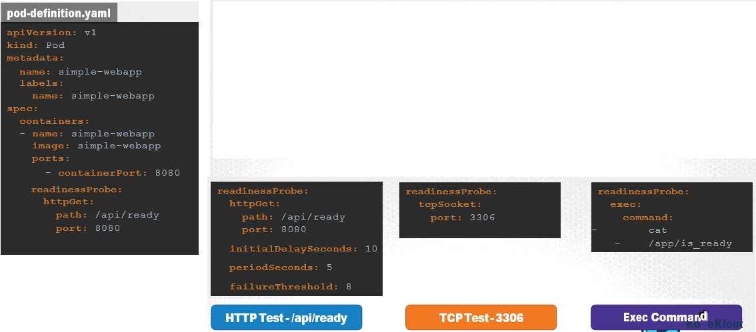

### Liveness Probes

Every time the application crashes, kubernetes makes an attempt to restart the container to restore service to users. You can see the count of restarts increase.

kubectl get pods

However, what if the application is not really working but the container continues to stay alive? Say for example, due to a bug in the code, the application is stuck in an infinite loop. As far as kubernetes is concerned, the container is up, so the application is assumed to be up. But the users hitting the container are not served. In that case, the container needs to be restarted, or destroyed and a new container is to be brought up. That is where the liveness probe can help us.

A liveness probe can be configured on the container to periodically test whether the application within the container is actually healthy. If the test fails, the container is considered unhealthy and is destroyed and recreated.

In case of a web application it could be when the API server is up and running.

In case of database, you may test to see if a particular TCP socket is listening.

Or You may simply execute a command to perform a test.

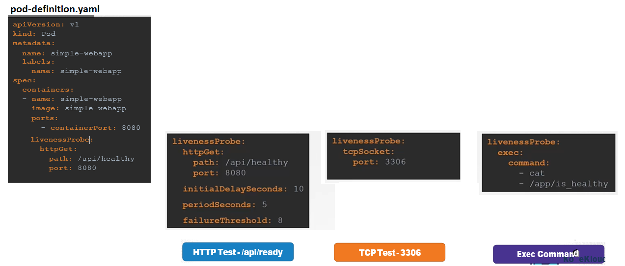

Let us look at how readinessProbes are useful in a multi-pod setup. Say you have a replica set or deployment with multiple pods. And a service serving traffic to all the pods. There are two PODs already serving users. Say you were to add an additional pod. And let’s say the Pod takes a minute to warm up. Without the readinessProbe configured correctly, the service would immediately start routing traffic to the new pod. That will result in service disruption to atleast some of the users.

Instead if the pods were configured with the correct readinessProbe, the service will continue to serve traffic only to the older pods and wait until the new pod is ready. Once ready, traffic will be routed to the new pod as well, ensuring no users are affected.

### Container Logging

**Docker Logs**

docker logs -f <container-id>

**Kubernetes Logs**

kubectl logs -f <pod-name> <container-name>

### Monitoring Kubernetes

So how do you monitor resource consumption on Kubernetes? Or more importantly what would you like to monitor? I’d like to know Node level metrics such as the number of nodes in the cluster, how many of them are healthy as well as performance metrics such as CPU. Memory, network and disk utilization.

As well as POD level metrics such as the number of PODs, and performance metrics of each POD such the CPU and Memory consumption. So we need a solution that will monitor these metrics, store them and provide analytics around this data.

As of this recording , Kubernetes does not come with a full featured built-in monitoring solution. However, there are a number of open-source solutions available today, such as the Metrics-Server, Prometheus, the Elastic Stack, and proprietary solutions like Datadog and Dynatrace.

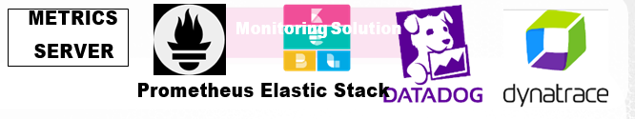

**Metrics Server**

You can have one metrics server per kubernetes cluster.

Metrics server is only an in-memory monitoring solution and does not store the metrics on the disk, and as a result you cannot see historical performance data. For that you must rely on one of the advanced monitoring solutions.

So how are the metrics generated for the PODs on these nodes? Kubernetes runs an agent on each node known as the **kubelet**, which is responsible for receiving instructions from the kubernetes API master server and running PODs on the nodes. The kubelet also contains a subcomponent known as as **cAdvisor** or Container Advisor. cAdvisor is responsible for retrieving performance metrics from pods, and exposing them through the kubelet API to make the metrics available for the Metrics Server.

**Metric Server Setup**

git clone https://github.com/kubernetes-incubator/metrics-server.git

cd <metric-server-folder>

kubectl create -f .

**Metrics Commands:**

kubectl top node

kubectl top pod

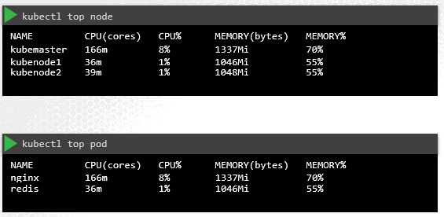

# POD Design

### Labels, Selectors & Annotations

Labels and Selectors are a standard method to group things together. A user wants to be able to filter them based on different criteria. Labels are properties attached to each object. Selectors help you filter these objects.

So how are labels and selectors used in Kubernetes? We have created a lot of different types of Objects in Kuberentes. Pods, Services, ReplicaSets and Deployments. For Kubernetes, all of these are different objects. Over time you may end up having 100s and 1000s of these objects in your cluster. Then you will need a way to filter and view different objects by different categories. Like

* View objects by their type (eg- Pod, Service, ReplicaSet, Deployment)
* View objects by application (eg- app-server, web-server, db-server, cache-server)
* View objects by their functionality (eg- frontend, backend)

So how exactly do you specify labels in kubernetes. In a pod-definition file, under metadata, create a section called labels. Under that add the labels in a key value format like this. You can add as many labels as you like.

**Labels in Pod**

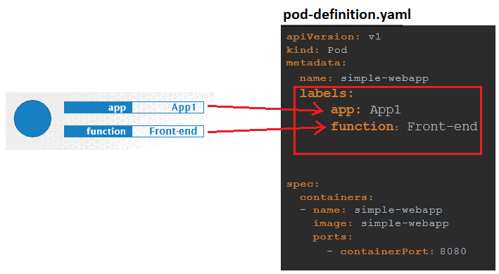

**Labels in ReplicaSet**

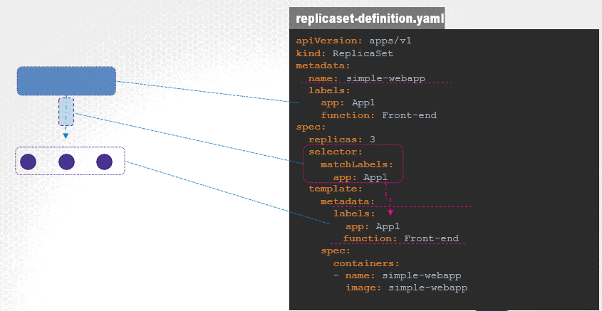

Note- In replicaset, the labels specified under the “matchLabels” section and labels specified in template/metadata section need to be same.

On creation, if the labels match, the replicaset is created successfully

**Labels in Service**

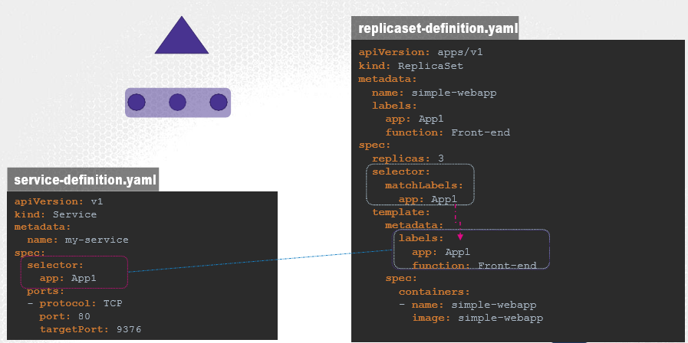

When a service is created, it uses the selector defined in the service definition file to match the labels set on the pods in the replicaset-definition file.

**Annotations**

While labels and selectors are used to group and select objects, **annotations are used to record other details for informatory purpose**. For example, tool details like name, version build information etc. or contact details, phone numbers, email ids etc., that may be used for some kind of integration purpose.

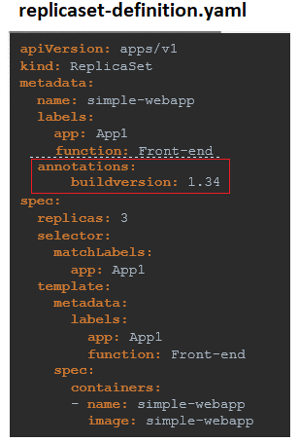

#### Q&A

**(1) How many pods are in dev env**

kubectl get pods --selector env=dev

**(2) How many objects are in the 'prod' environment including PODs, ReplicaSets and any other objects?**

kubectl get all --selector env=prod

**(3) Identify the POD which is 'prod', part of 'finance' BU and is a 'frontend' tier?**

kubectl get pods --selector env=prod,bu=finance,tier=frontend

### Rolling Updates & Rollbacks

When you upgrade your instances, you do not want to upgrade all of them at once as we just did. This may impact users accessing our applications, so you may want to upgrade them one after the other. And that kind of upgrade is known as **Rolling Updates.**

Suppose one of the upgrades you performed resulted in an unexpected error and you are asked to undo the recent update. You would like to be able to **rollback** the changes that were recently carried out.

Finally, say for example you would like to make multiple changes to your environment

such as upgrading the underlying WebServer versions, as well as scaling your environment and also modifying the resource allocations etc. You do not want to apply each change immediately after the command is run, instead you would like to apply a pause to your environment, make the changes and then resume so that all changes are rolled-out together.

All of these capabilities are available with the kubernetes Deployments.

Each container is encapsulated in PODs. Multiple such PODs are deployed using Replication Controllers or Replica Sets. And then comes Deployment which is a kubernetes object that comes higher in the hierarchy. The deployment provides us with capabilities to upgrade the underlying instances seamlessly using rolling updates, undo changes, and pause and resume changes to deployments.

#### Summarize Commands

|  |  |
| --- | --- |
| Create | kubectl create -f deployment-definition.yml  kubectl create -f deployment-definition.yml --record (This records the change cause in history) |
| Get | kubectl get deployments |
| Update | kubectl apply -f deployment-definition.yml  kubectl set image deployment/myapp-deployment nginx=nginx:1.9.1 |
| Status | kubectl rollout status deployment/myapp-deployment  kubectl rollout history deployment/myapp-deployment |
| Rollback | kubectl rollout undo deployment/myapp-deployment |

#### Updating a Deployment

Here are some handy examples related to updating a Kubernetes Deployment:

* **Creating a deployment, checking the rollout status and history:**

In the example below, we will first **create** a simple deployment and inspect the **rollout status** and the **rollout history**:

1. master $ kubectl create deployment nginx --image=nginx:1.16
2. deployment.apps/nginx created
4. master $ kubectl rollout status deployment nginx
5. Waiting for deployment "nginx" rollout to finish: 0 of 1 updated replicas are available...
6. deployment "nginx" successfully rolled out
8. master $

11. master $ kubectl rollout history deployment nginx
12. deployment.extensions/nginx
13. REVISION CHANGE-CAUSE
14. 1     <none>
16. master $

* **Using the --revision flag:**

Here the revision 1 is the first version where the deployment was created.

You can check the status of each revision individually by using the **--revision flag**:

1. master $ kubectl rollout history deployment nginx --revision=1
2. deployment.extensions/nginx with revision #1
4. Pod Template:
5. Labels:    app=nginx    pod-template-hash=6454457cdb
6. Containers:  nginx:  Image:   nginx:1.16
7. Port:    <none>
8. Host Port: <none>
9. Environment:    <none>
10. Mounts:   <none>
11. Volumes:   <none>
12. master $

* **Using the --record flag:**

You would have noticed that the "**change-cause**" field is empty in the rollout history output. We can use the **--record flag** to save the command used to create/update a deployment against the revision number.

1. master $ kubectl set image deployment nginx nginx=nginx:1.17 --record
2. deployment.extensions/nginx image updated
3. master $master $
5. master $ kubectl rollout history deployment nginx
6. deployment.extensions/nginx
8. REVISION CHANGE-CAUSE
9. 1     <none>
10. 2     kubectl set image deployment nginx nginx=nginx:1.17 --record=true
11. master $

You can now see that the **change-cause** is recorded for the revision 2 of this deployment.

Let's make some more changes. In the example below, we are editing the deployment and changing the image from **nginx:1.17** to **nginx:latest** while making use of the --record flag.

1. master $ kubectl edit deployments. nginx --record
2. deployment.extensions/nginx edited
4. master $ kubectl rollout history deployment nginx
5. REVISION CHANGE-CAUSE
6. 1     <none>
7. 2     kubectl set image deployment nginx nginx=nginx:1.17 --record=true
8. 3     kubectl edit deployments. nginx --record=true


12. master $ kubectl rollout history deployment nginx --revision=3
13. deployment.extensions/nginx with revision #3
15. Pod Template: Labels:    app=nginx
16. pod-template-hash=df6487dc Annotations: kubernetes.io/change-cause: kubectl edit deployments. nginx --record=true
18. Containers:
19. nginx:
20. Image:   nginx:latest
21. Port:    <none>
22. Host Port: <none>
23. Environment:    <none>
24. Mounts:   <none>
25. Volumes:   <none>
27. master $

* **Undo a change:**

Let’s now rollback to the previous revision:

1. master $ kubectl rollout undo deployment nginx
2. deployment.extensions/nginx rolled back
4. master $ kubectl rollout history deployment nginx
5. deployment.extensions/nginxREVISION CHANGE-CAUSE
6. 1     <none>
7. 3     kubectl edit deployments. nginx --record=true
8. 4     kubectl set image deployment nginx nginx=nginx:1.17 --record=true



13. master $ kubectl rollout history deployment nginx --revision=4
14. deployment.extensions/nginx with revision #4Pod Template:
15. Labels:    app=nginx    pod-template-hash=b99b98f9
16. Annotations: kubernetes.io/change-cause: kubectl set image deployment nginx nginx=nginx:1.17 --record=true
17. Containers:
18. nginx:
19. Image:   nginx:1.17
20. Port:    <none>
21. Host Port: <none>
22. Environment:    <none>
23. Mounts:   <none>
24. Volumes:   <none>

27. master $ kubectl describe deployments. nginx | grep -i image:
28. Image:    nginx:1.17
29. master $

With this, we have rolled back to the previous version of the deployment with the **image = nginx:1.17.**

#### Q&A

**(1) Inspect the deployment and identify the image used**

kubectl describe deployment <deployment-name> | grep -i image

**(2) Inspect the deployment and identify the current strategy**

kubectl describe deployment <deployment-name> | grep -i strategy

**(3) Update the image of the existing deployment**

kubectl set image deployment/<deployment-name> <container-name>=<new-image-name>

**(4) Change the deployment strategy to 'Recreate'**

**Do not delete and re-create the deployment. Only update the strategy type for the existing deployment.**

Run the command 'kubectl edit deployment frontend' and modify the required field. Make sure to delete the properties of rollingUpdate as well, set at 'strategy.rollingUpdate'.

**(5) Upgrade the application by setting the image on the deployment to 'kodekloud/webapp-color:v3'**

**Do not delete and re-create the deployment. Only set the new image name for the existing deployment.**

kubectl set image deployment/frontend simple-webapp=kodekloud/webapp-color:v2

### Jobs

There are different types of workloads that a container can serve. A few that we have seen through this course are Web, application and database. We have deployed simple web servers that serve users. These workloads are meant to continue to run for a long period of time, until manually taken down. There are other kinds of workloads such as batch processing, analytics or reporting that are meant to carry out a specific task and then finish.

For example, performing a computation, processing an image, performing some kind of analytics on a large data set, generating a report and sending an email etc. These are workloads that are meant to live for a short period of time, perform a set of tasks and then finish.

Job Definition

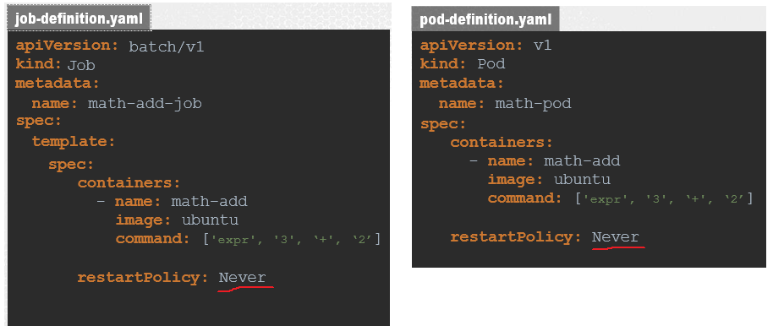

**Create, View & Delete Jobs**

kubectl create -f job-definition.yaml

kubectl get jobs

kubectl get pods

kubectl logs math-add-job-ld87pn

kubectl delete job math-add-job

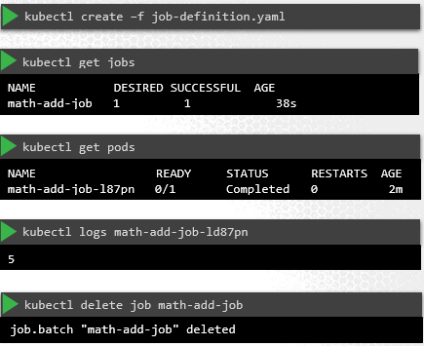

The standard output of a container can be seen using the logs command. So we run the kubectl logs command with the name of the pod to see the output. Finally, to delete the job, run the kubetcl delete job command. Deleting the job will also result in deleting the pods that were created by the job.

**Jobs with Multiple PODs**

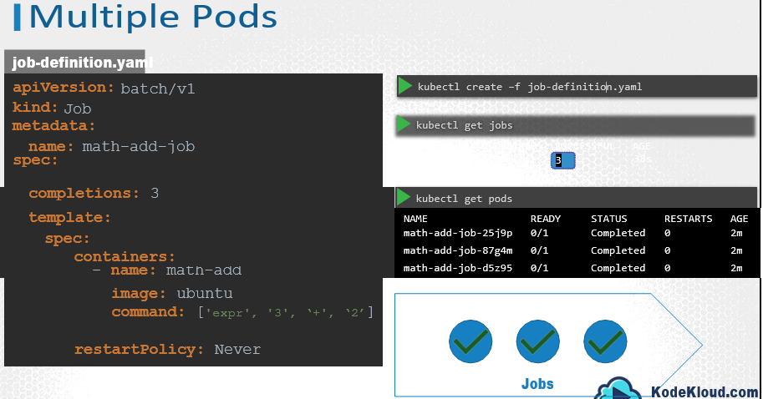

To run multiple pods, we set a value for completions under the job specification. And we set it to 3 to run 3 PODs. This time, when we create the job, We see the Desired count is 3, and the successful count is 0. Now, by default, the PODs are created one after the other. The second pod is created only after the first is finished.

That was straight forward. But what if the pods fail? For example, I am now going to create a job using a different image called random-error. It’s a simple docker image that randomly completes or fails. When I create this job, first pod completes successfully, the second one fails, so a third one is created and that completes successfully and the fourth one fails, and so does the fifth one and so to have 3 completions, the job creates a new pod which happen to complete successfully. And that completes the job.

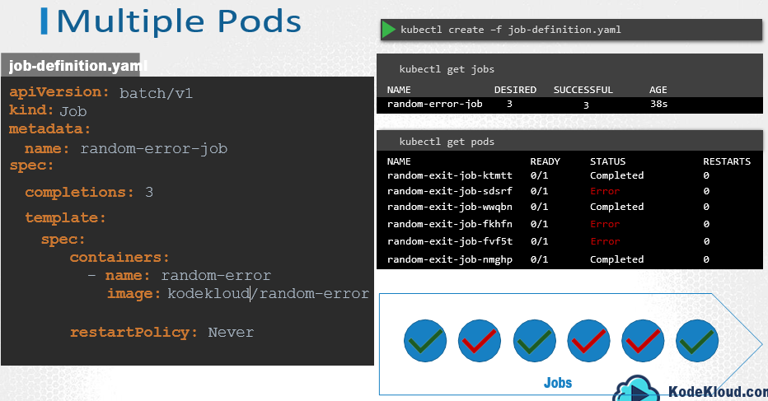

Instead of getting the pods created sequentially we can get them created in parallel. For this add a property called parallelism to the job specification. We set it to 3 to create 3 pods in parallel. So the job first creates 3 pods at once. Two of which completes successfully. So we only need one more, so it’s intelligent enough to create one pod at a time until we get a total of 3 completed pods.

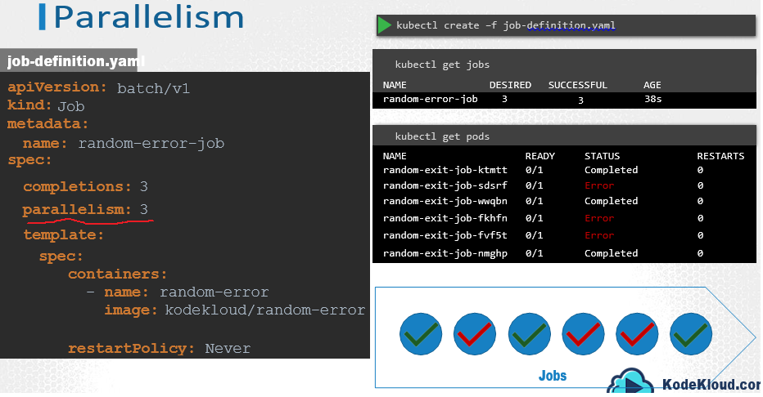

### CronJobs

A cronjob is a job that can be scheduled. Just like cron tab in Linux, if you are familiar with it. Say for example you have a job that generates a report and sends an email. You can create the job using the kubectl create command, but it runs instantly.

Instead you could create a cronjob to schedule and run it periodically.

**Create CronJob**

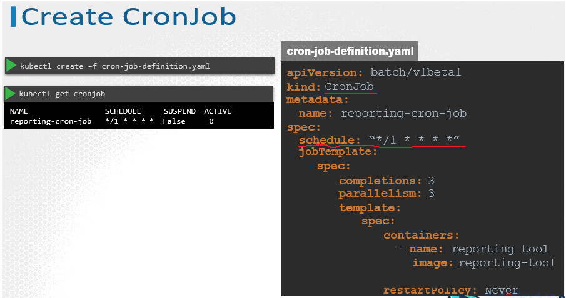

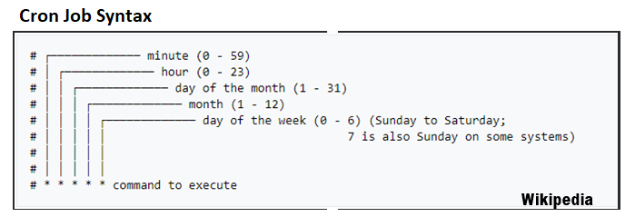

# Services and Networking

### Services- NodePort, ClusterIP

Kubernetes Services enable communication between various components within and outside of the application. Kubernetes Services helps us connect applications together with other applications or users. For example, our application has groups of PODs running various sections, such as a group for serving front-end load to users, another group running back-end processes, and a third group connecting to an external data source. It is Services that enable connectivity between these groups of PODs. Services enable the front-end application to be made available to users, it helps communication between back-end and front-end PODs, and helps in establishing connectivity to an external data source. Thus services enable loose coupling between microservices in our application.

The kubernetes service is an object just like PODs, Replicaset or Deployments that we worked with before. One of its use case is to listen to a port on the Node and forward requests on that port to a port on the POD running the web application.

A Service can help us by mapping a port on the Node to a port on the POD.

**Services Types**

**3 types: NodePort, ClusterIP, LoadBalancer**

**NodePort:**

In NodePort type, the service makes an internal POD accessible on a Port on the Node.

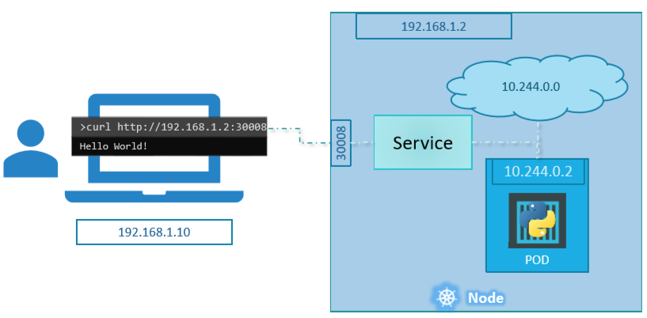

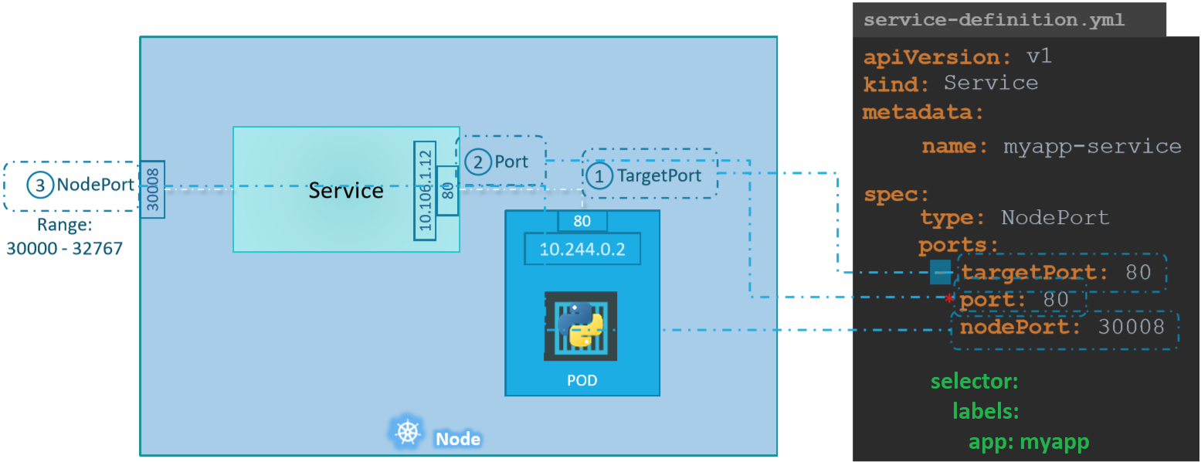

Let’s take a closer look at the Service. If you look at it, there are 3 ports involved. The port on the POD were the actual web server is running is port 80. And it is referred to as the targetPort, because that is where the service forwards the requests to. The second port is the port on the service itself. It is simply referred to as the port. Remember, these terms are from the viewpoint of the service. The service is in fact like a virtual server inside the node. Inside the cluster it has its own IP address. And that IP address is called the Cluster-IP of the service. And finally we have the port on the Node itself which we use to access the web server externally. And that is known as the NodePort. As you can see it is 30008. That is because NodePorts can only be in a valid range which is from 30000 to 32767.

The type refers to the type of service we are creating. As discussed before it could be ClusterIP, NodePort, or LoadBalancer

labels and selectors are used to link these together. We know that the POD was created with a label. We need to bring that label into this service definition file.

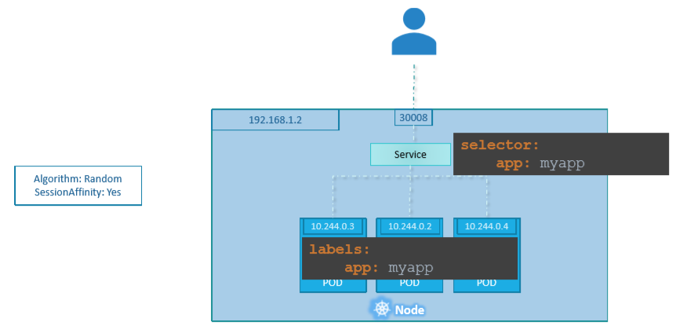

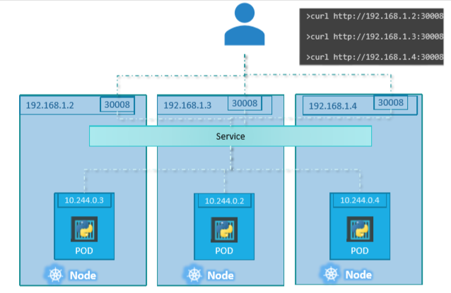

**ClusterIP:**

In ClusterIP type, the service creates a virtual IP inside the cluster to enable communication between different services such as a set of front-end servers to a set of backendservers.

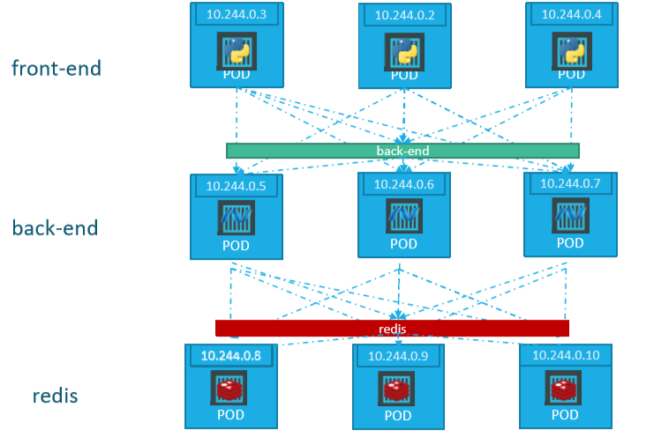

A full stack web application typically has different kinds of PODs hosting different parts of an application. You may have a number of PODs running a front-end web server, another set of PODs running a backend server, a set of PODs running a key-value store like Redis, another set of PODs running a persistent database like MySQL etc. The web front-end servers need to connect to the backend-workers and the backend-workers need to connect to database as well as the redis services. So what IS the right way to establish connectivity between these PODs?

The PODs all have an IP address assigned to them as we can see on the screen. But these Ips as we know are not static, these PODs can go down anytime and new PODs are created all the time – and so you CANNOT rely on these IP addresses for internal communication within the application. Also what if the first front-end POD at 10.244.0.3 need to connect to a backend service? Which of the 3 would it go to and who makes that decision?

A kubernetes service can help us group these PODs together and provide a single interface to access the PODs in a group. For example a service created for the backend PODs will help group all the backend PODs together and provide a single interface for other PODs to access this service. The requests are forwarded to one of the PODs under the service randomly. Similarly, create additional services for Redis and allow the backend PODs to access the redis system through this service. This enables us to easily and effectively deploy a microservices based application on kubernetes cluster. Each layer can now scale or move as required without impacting communication between the various services. Each service gets an IP and name assigned to it inside the cluster and that is the name that should be used by other PODs to access the service. This type of service is known as ClusterIP.

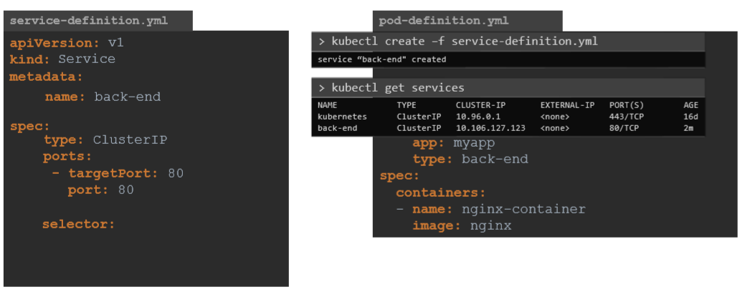

ClusterIP is the default Service Type, so even if you didn’t specify it, it will automatically assume it to be ClusterIP.

**LoadBalancer:**

In LoadBalancer type, it provisions a load balancer for our service in supported cloud providers. A good example of that would be to distribute load across different web servers.

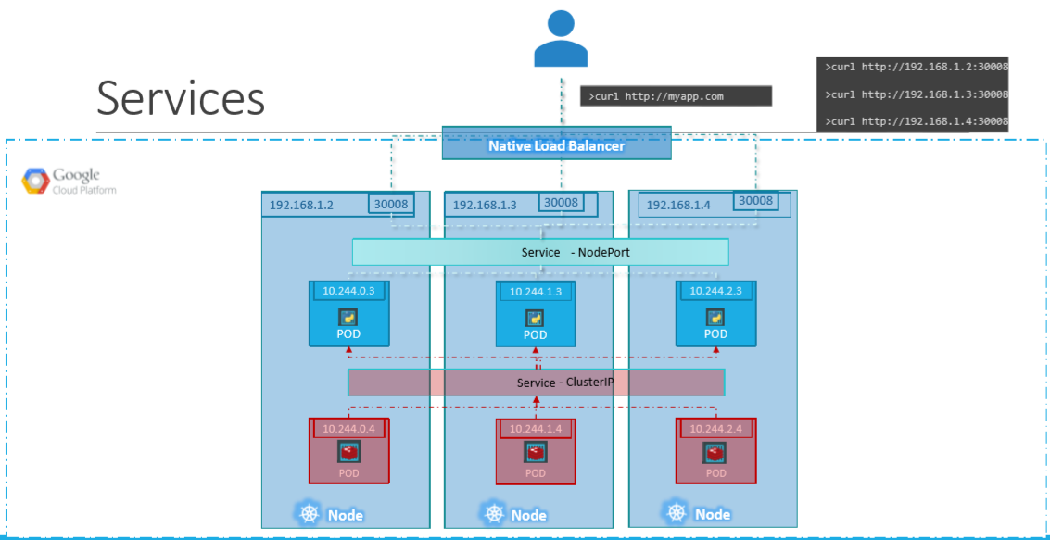

We will quickly recap what we learned about the two service types, so that we can work our way to the LoadBalancer type. We have a 3 node cluster with Ips 192.168.1.2,3 and 4. Our application is two tier, there is a database service and a front-end web service for users to access the application. The default service type – known as ClusterIP – makes a service, such as a redis or database service available internally within the kubernetes cluster for other applications to consume.

The next tier in my application happens to be a python based web front-end. This application connects to the backend using Service created for the redis service. To expose the application to the end users, we create another service of type NodePort. Creating a service of type NodePort exposes the application on a high end port of the Node and the users can access the application at any IP of my nodes with the port 30008.

Now, what IP do you give your end users to access your application? You cannot give them all three and let them choose one of their own. What end users really want is a single URL to access the application. For this, you will be required to setup a separate Load Balancer VM in your environment. In this case I deploy a new VM for load balancer purposes and configure it to forward requests that come to it to any of the IPs of the Kubernetes nodes. I will then configure my organizations DNS to point to this load balancer when a user hosts http://myapp.com. Now setting up that load balancer by myself is a tedious task, and I might have to do that in my local or onprem environment. However, if I happen to be on a supported CloudPlatform, like Google Cloud Platform, I could leverage the native load balancing functionalities of the cloud platform to set this up. Again you don’t have to set that up manually, Kubernetes sets it up for you. Kubernetes has built-in integration with supported cloud platforms.

### Ingress Networking

Ingress exposes HTTP and HTTPS routes from outside the cluster to [services](https://kubernetes.io/docs/concepts/services-networking/service/) within the cluster. Traffic routing is controlled by rules defined on the Ingress resource.

internet

|

[ Ingress ]

--|-----|--

[ Services ]

An Ingress may be configured to give Services externally-reachable URLs, load balance traffic, terminate SSL / TLS, and offer name based virtual hosting. An [Ingress controller](https://kubernetes.io/docs/concepts/services-networking/ingress-controllers) is responsible for fulfilling the Ingress, usually with a load balancer, though it may also configure your edge router or additional frontends to help handle the traffic.

An Ingress does not expose arbitrary ports or protocols. Exposing services other than HTTP and HTTPS to the internet typically uses a service of type [Service.Type=NodePort](https://kubernetes.io/docs/concepts/services-networking/service/#nodeport) or [Service.Type=LoadBalancer](https://kubernetes.io/docs/concepts/services-networking/service/#loadbalancer).

You may need to deploy an Ingress controller such as [**ingress-nginx**](https://kubernetes.github.io/ingress-nginx/deploy/). You can choose from a number of [Ingress controllers](https://kubernetes.io/docs/concepts/services-networking/ingress-controllers).

Ideally, all Ingress controllers should fit the reference specification. In reality, the various Ingress controllers operate slightly differently.

Ingress helps your users access your application using a single Externally accessible URL, that you can configure to route to different services within your cluster based on the URL path, at the same time terminate TLS.

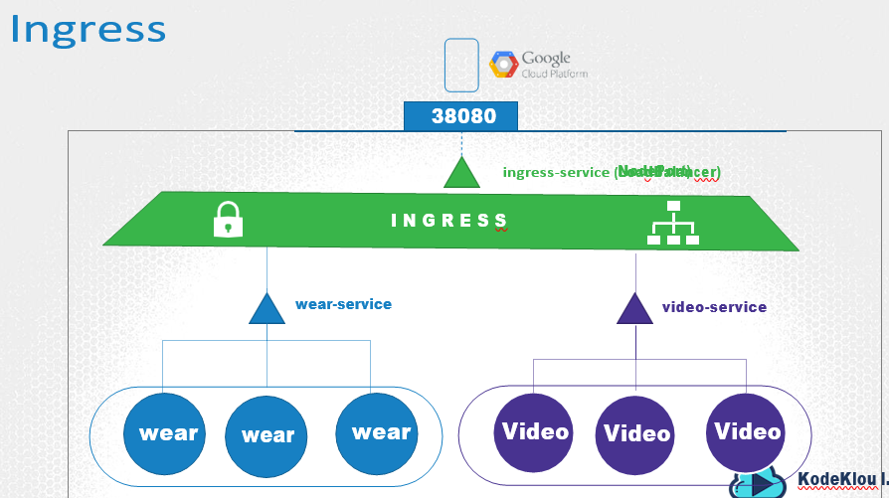

Simply put, think of ingress as a **layer 7 load balancer** built-in to the kubernetes cluster that can be configured using native kubernetes primitives just like any other object in kubernetes.

Now remember, even with Ingress you still need to expose it to make it accessible outside the cluster. So you still have to either publish it as a NodePort or with a Cloud Native LoadBalancer. But that is just a one time thing. Going forward you are going to perform all your load balancing, Auth, SSL and URL based routing configurations on the Ingress controller.

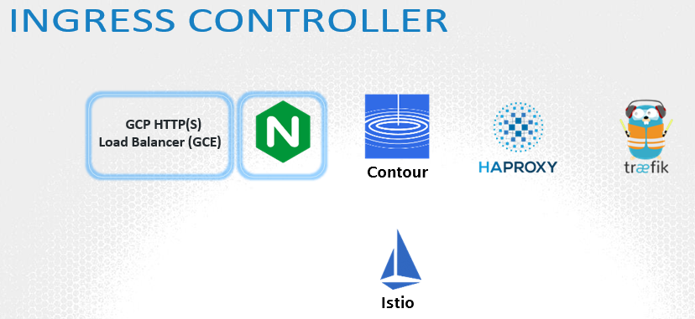

kubernetes cluster does NOT come with an Ingress Controller by default.

In Ingress, you first deploy a supported solution, which happens to be any of these listed here, and then specify a set of rules to configure Ingress. The solution you deploy is called as an **Ingress Controller**. And the set of rules you configure is called as **Ingress Resources**. Ingress resources are created using definition files like the ones we used to create PODs, Deployments and services.

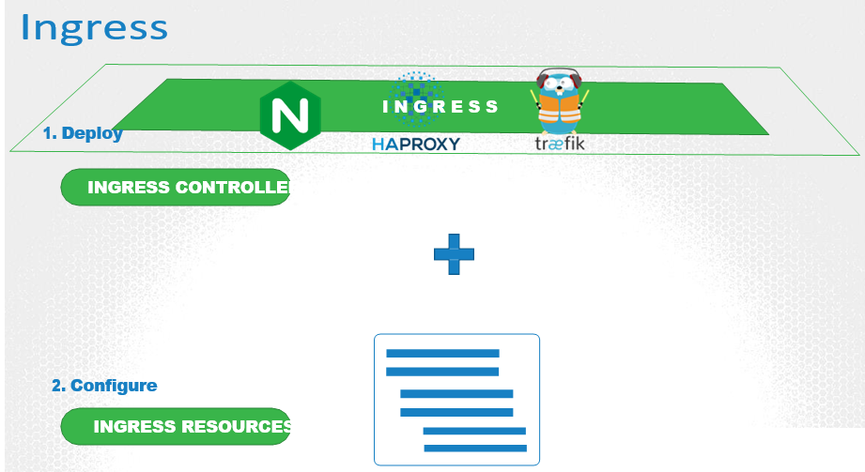

#### Ingress Controller

An NGINX Controller is deployed as just another deployment in Kubernetes. So we start with a deployment file definition, named nginx-ingress-controller. With 1 replica and a simple pod definition template. We will label it nginx-ingress and the image used is nginx-ingress-controller with the right version. This is a special build of NGINX built specifically to be used as an ingress controller in kubernetes. So it has its own requirements. Within the image the nginx program is stored at location /nginx-ingress-controller. So you must pass that as the command to start the nginx-service. If you have worked with NGINX before, you know that it has a set of configuration options such as the path to store the logs, keep-alive threshold, ssl settings, session timeout etc. In order to decouple these configuration data from the nginx-controller image, you must create a ConfigMap object and pass that in. Now remember the ConfigMap object need not have any entries at this point. A blank object will do. But creating one makes it easy for you to modify a configuration setting in the future. You will just have to add it in to this ConfigMap.

You must also pass in two environment variables that carry the POD’s name and namespace it is deployed to. The nginx service requires these to read the configuration data from within the POD.

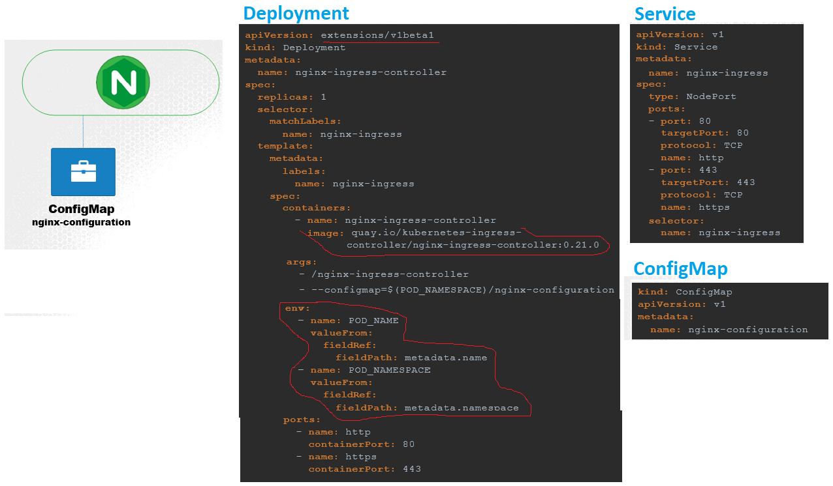

We then need a service to expose the ingress controller to the external world. So we create a service of type NodePort with the nginx-ingress label selector to link the service to the deployment.

So with these three objects we should be ready with an ingress controller in its simplest form.

#### Ingress Resources

An Ingress Resource is a set of rules and configurations applied on the ingress controller. You can configure rules to say, simply forward all incoming traffic to a single application, or route traffic to different applications based on the URL. So if user goes to my-online-store.com/wear, then route to one app, or if the user visits the /watch URL then route to the video app. Or you could route user based on the domain name itself.

The Ingress Resource is created with a Kubernetes Definition file. In this case, ingress-wear.yaml. As with any other object, we have apiVersion, kind, metadata and spec. The apiVersion is extensions/v1beta1, kind is Ingress, we will name it ingress-wear. And under spec we have backend.

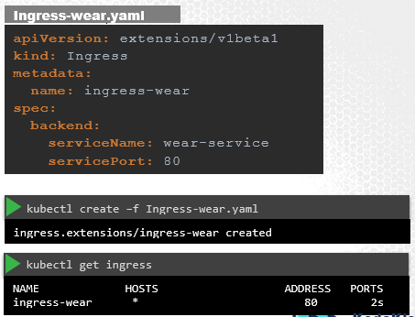

As you might have guessed already, traffic is routed to the application services and not PODs directly. The Backend section defines where the traffic will be routed to. So if it’s a single backend, then you don’t really have any rules. You can simply specify the service name and port of the backend wear service. Create the ingress resource by running the kubectl create command. View the created ingress by running the kubectl get ingress command. The new ingress is now created and routes all incoming traffic directly to the wear-service.

You use rules, when you want to route traffic based on different conditions. For example, you create one rule for traffic originating from each domain or hostname. That means when users reach your cluster using the domain name, my-online- store.com, you can handle that traffic using rule1. When users reach your cluster using domain name wear.my-online-store.com, you can handle that traffic using a separate Rule2. Use Rule3 to handle traffic from watch.my-online-store.com. And say use a 4th rule to handle everything else. And you would achieve this, by adding multiple DNS entries, all of which would point to the same Ingress controller service on your kubernetes cluster.

Now within each rule you can handle different paths.

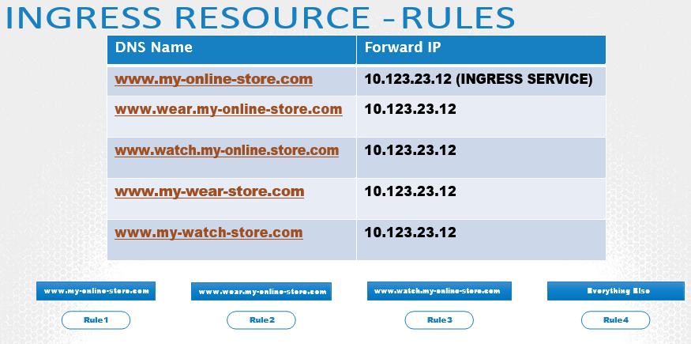

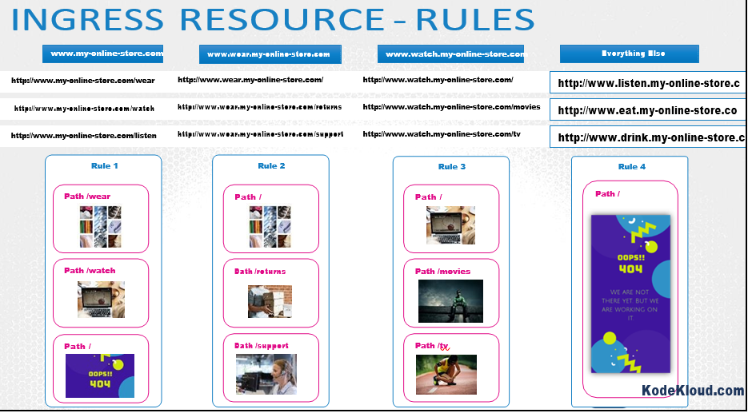

To split traffic by domain name, we use the host field. The host field in each rule matches the specified value with the domain name used in the request URL and routes traffic to the appropriate backend. In this case note that we only have a single backend path for each rule. Which is fine. All traffic from these domain names will be routed to the appropriate backend irrespective of the URL Path used. You can still have multiple path specifications in each of these to handle different URL paths.

Splitting traffic by URL had just one rule and we split the traffic with two paths. To split traffic by hostname, we used two rules and one path specification in each rule.

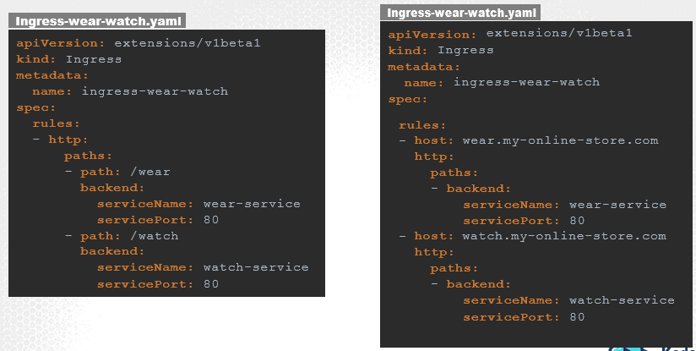

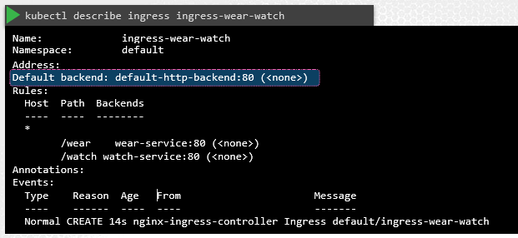

References

**Bare-metal Considerations**

https://kubernetes.github.io/ingress-nginx/deploy/baremetal/ https://github.com/kubernetes/ingress-gce/blob/master/README.md https://kubernetes.github.io/ingress-nginx/deploy/ https://kubernetes.github.io/ingress-nginx/user-guide/nginx-configuration/

#### Q&A

**(1) How many applications are deployed in the app-space namespace?**

**Count the number of deployments in this namespace**

kubectl get deploy --namespace app-space

**(2) Which namespace is the Ingress Resource deployed in?**

kubectl get ingress --all-namespaces

**(3) A new payment service has been introduced. Since it is critical, the new application is deployed in its own namespace.**

**Identify the namespace in which the new application is deployed**

kubectl get deploy --all-namespaces

**(4) How to edit a ingress**

kubectl edit ingress ingress-pay --namespace=critical-space

**(5) How to extract the ingress definition file from an existing one in a namespace**

kubectl get ingress ingress-pay --namespace=critical-space -o yaml > ingress-pay.yaml

#### rewrite-target option

FAQ - What is the rewrite-target option?

Different ingress controllers have different options that can be used to customise the way it works. NGINX Ingress controller has many options that can be seen [here](https://kubernetes.github.io/ingress-nginx/examples/). I would like to explain one such option that we will use in our labs. The [Rewrite](https://kubernetes.github.io/ingress-nginx/examples/rewrite/) target option.

Our watch app displays the video streaming webpage at http://<watch-service>:<port>/

Our wear app displays the apparel webpage at http://<wear-service>:<port>/

We must configure Ingress to achieve the below. When user visits the URL on the left, his request should be forwarded internally to the URL on the right. Note that the /watch and /wear URL path are what we configure on the ingress controller so we can forward users to the appropriate application in the backend. The applications don't have this URL/Path configured on them:  
  
http://<ingress-service>:<ingress-port>/watch --> http://<watch-service>:<port>/

http://<ingress-service>:<ingress-port>/wear --> http://<wear-service>:<port>/

Without the rewrite-target option, this is what would happen:

http://<ingress-service>:<ingress-port>/watch --> http://<watch-service>:<port>/watch

http://<ingress-service>:<ingress-port>/wear --> http://<wear-service>:<port>/wear

Notice watch and wear at the end of the target URLs. The target applications are not configured with /watch or /wear paths. They are different applications built specifically for their purpose, so they don't expect /watch or /wear in the URLs. And as such the requests would fail and throw a 404 not found error.

To fix that we want to "ReWrite" the URL when the request is passed on to the watch or wear applications. We don't want to pass in the same path that user typed in. So we specify the rewrite-target option. This rewrites the URL by replacing whatever is under rules->http->paths->path which happens to be /pay in this case with the value in rewrite-target. This works just like a search and replace function.

For example: replace(path, rewrite-target)  
In our case: replace("/path","/")

1. apiVersion: extensions/v1beta1
2. kind: Ingress
3. metadata:
4. name: test-ingress
5. namespace: critical-space
6. annotations:
7. nginx.ingress.kubernetes.io/rewrite-target: /
8. spec:
9. rules:
10. - http:
11. paths:
12. - path: /pay
13. backend:
14. serviceName: pay-service
15. servicePort: 8282

In another example given [here](https://kubernetes.github.io/ingress-nginx/examples/rewrite/), this could also be:

replace("/something(/|$)(.*)", "/$2")

1. apiVersion: extensions/v1beta1
2. kind: Ingress
3. metadata:
4. annotations:
5. nginx.ingress.kubernetes.io/rewrite-target: /$2
6. name: rewrite
7. namespace: default
8. spec:
9. rules:
10. - host: rewrite.bar.com
11. http:
12. paths:
13. - backend:
14. serviceName: http-svc
15. servicePort: 80
16. path: /something(/|$)(.*)

### Network Policies

We will start with a simple example of a traffic through a web, app and database server. So you have a web server serving front-end to users, an app server serving backend API’s and a database server. The user sends in a request to the web server at port 80. The web server then sends a request to the API server at port 5000 in the backend. The API server then fetches data from the database server at port 3306. And then sends the data back to the user. A very simple setup.

So there are two types of traffic here. Ingress and Egress. For example, for a web server, the incoming traffic from the users is an Ingress Traffic. And the outgoing requests to the app server is Egress traffic. And that is denoted by the straight arrow. **When you define ingress and egress, remember you are only looking at the direction in which the traffic originated.** The response back to the user, denoted by the dotted lines do not really matter.

Similarly, in case of the backend API server, it receives ingress traffic from the web server on port 80 and has egress traffic to port 3306 to the database server.

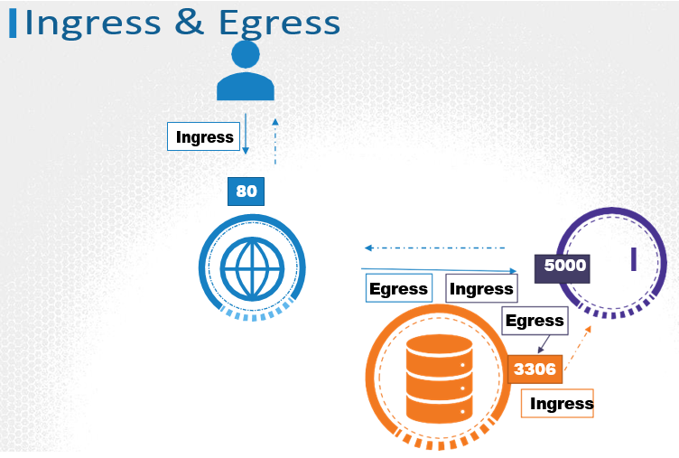

And from the database servers perspective, it receives Ingress traffic on port 3306 from the API server.

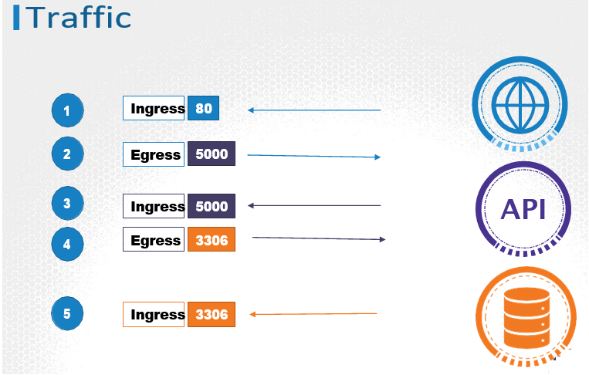

If we were to list the rules required to get this working, we would have an

1. Ingress rule that is required to accept HTTP traffic on port 80 on the web server.
2. An Egress rule to allow traffic from the web server to port 5000 on the API server.
3. An ingress rule to accept traffic on port 5000 on the API server
4. An egress rule to allow traffic to port 3306 on the database server.
5. An ingress rule on the database server to accept traffic on port 3306.

So that’s traffic flow and rules basics.

A Network policy is another object in the kubernetes namespace. Just like PODs, ReplicaSets or Services. You apply a network policy on selected pods.

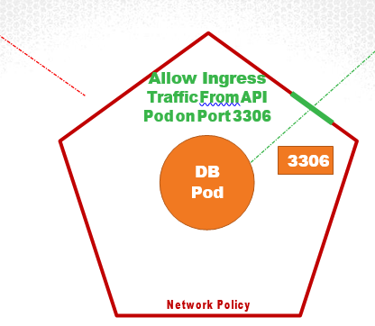

You link a network policy to one or more pods. You can define rules within the network policy. In this case I would say, only allow Ingress Traffic from the API Pod on Port 3306. Once this policy is created, it blocks all other traffic to the Pod and only allows traffic that matches the specified rule. Again, this is only applicable to the Pod on which the network policy is applied.

So how do you apply or link a network policy to a Pod? We use the same technique that was used before to link ReplicaSets or Services to Pods. Labels and Selectors. We label the Pod and use the same labels on the pod selector field in the network policy.

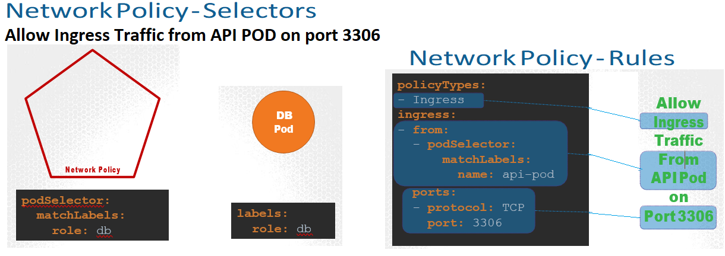

Let us put all that together. We start with a blank object definition file and as usual we have apiVersion, kind, metadata and spec. The apiVersion is networking.k8s.io/v1, the kind is NetworkPolicy. We will name the policy db-policy. And then under the spec section, we will first move the pod selector to apply this policy to the db pod.

Then we will move the rule we created in the previous slide under it. And that’s it. We have our first network policy ready. Run the kubectl create command to create the policy.

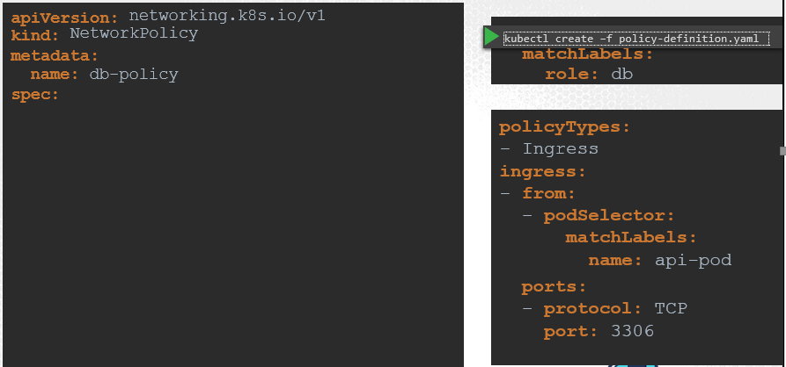

Always refer to the network solution’s documentation to see support for network policies. Also remember, even in a cluster configured with a solution that does not support network policies, you can still create the policies, but they will just not be enforced.



# State Persistence

### Volumes

Just as in Docker, the PODs created in Kubernetes are transient in nature. When a POD is created to process data and then deleted, the data processed by it gets deleted as well. For this we attach a volume to the POD. The data generated by the POD is now stored in the volume, and even after the POD is deleted, the data remains.

Let’s look at a simple implementation of volumes. We have a single node kubernetes cluster. We create a simple POD that generates a random between 1 and 100 and writes that to a file at /data/number.out and then gets deleted along with the random number. To retain the number generated by the pod, we create a volume.

And a Volume needs a storage. When you create a volume you can chose to configure it’s storage in different ways. We will look at the various options in a bit, but for now we will simply configure it to use a directory on the host. In this case I specify a path

/data on the host. This way any files created in the volume would be stored in the directory data on my node.

Once the volume is created, to access it from a container we mount the volume to a directory inside the container. We use the **volumeMounts** field in each container to mount the data-volume to the directory /opt within the container. The random number will now be written to /opt mount inside the container, which happens to be on the data-volume which is in fact /data directory on the host. When the pod gets deleted, the file with the random number still lives on the host.

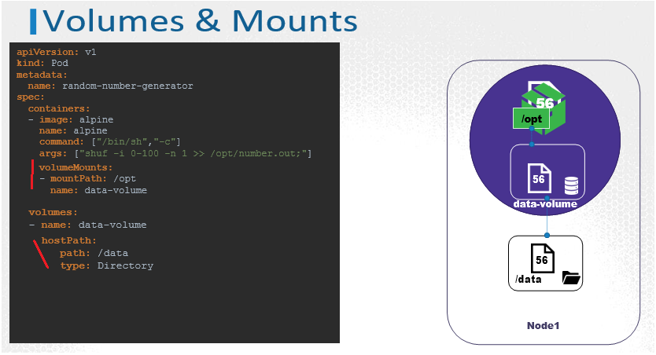

We just used the **hostPath** option to configure a directory on the host as storage space for the volume. Now that works on a single node. However, it is not recommended for use in a multi-node cluster. This is because the PODs would use the /data directory on all the nodes, and expect all of them to be the same and have the same data. Since they are on different servers, they are in fact not the same, unless you configure some kind of external replicated clustered storage solution.

Kubernetes supports several types of standard storage solutions such as NFS, glusterFS, Flocker, FibreChannel, CephFS, ScaleIO or public cloud solutions like AWS EBS, Azure Disk or File or Google’s Persistent Disk.

For example, to configure an AWS Elastic Block Store volume as the storage or the volume, we replace **hostPath** field of the volume with **awsElasticBlockStore** field along with the volumeID and filesystem type. The Volume storage will now be on AWS EBS.

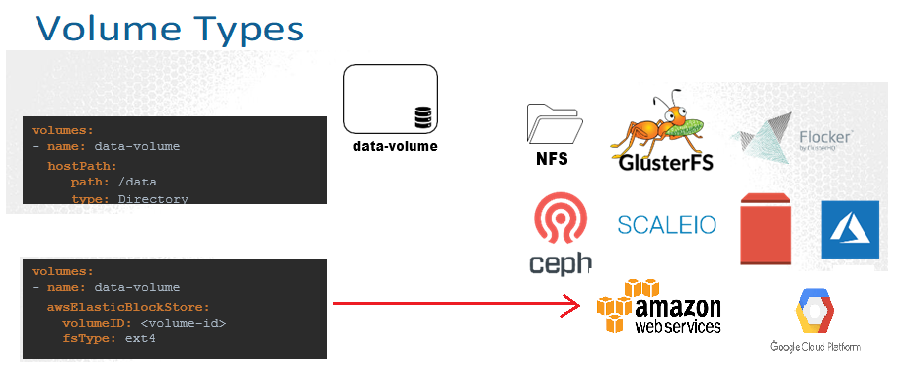

### Persistent Volumes

Every configuration information required to configure storage for the volume goes within the pod definition file. A Persistent Volume is a Cluster wide pool of storage volumes configured by an Administrator, to be used by users deploying applications on the cluster. The users can now select storage from this pool using Persistent Volume Claims.

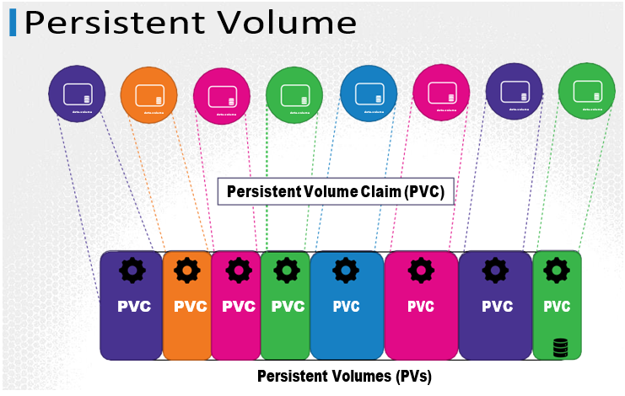

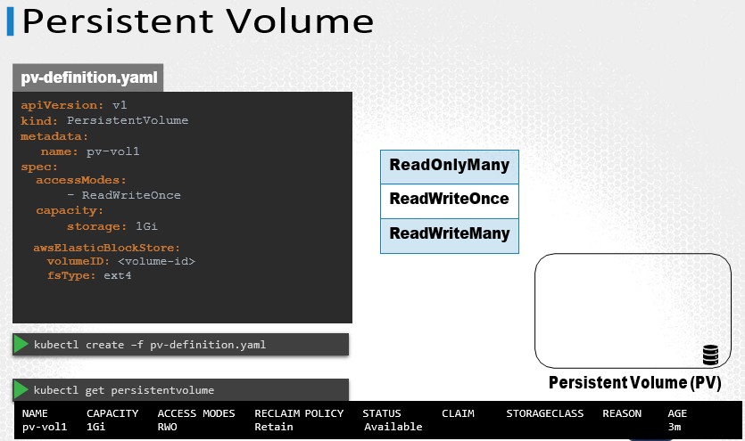

Let us now create a Persistent Volume. We start with the base template and update the apiVersion, set the Kind to PersistentVolume, and name it pv-vol1. Under the spec section specify the accessModes.

Access Mode defines how the Volume should be mounted on the hosts. Weather in a ReadOnly mode, or ReadWrite mode. The supported values are ReadOnlyMany, ReadWriteOnce or ReadWriteMany mode.

Next, is the capacity. Specify the amount of storage to be reserved for this Persistent Volume. Which is set to 1GB here.

Next comes the volume type. We will start with the hostPath option that uses storage from the node’s local directory. Remember this option is not to be used in a production environment.

To create the volume run the kubectl create command and to list the created volume run the kubectl get persistentvolume command.

Replace the hostPath option with one of the supported storage solutions as we aws in the previous lecture like AWS Elastic Block Store.

### Persistent Volume Claims

Persistent Volume Claim is made to make the storage available to a node.

Persistent Volumes and Persistent Volume Claims are two separate objects in the Kubernetes namespace. An Administrator creates a set of Persistent Volumes and a user creates Persistent Volume Claims to use the storage. Once the Persistent Volume Claims are created, Kubernetes binds the Persistent Volumes to Claims based on the request and properties set on the volume.

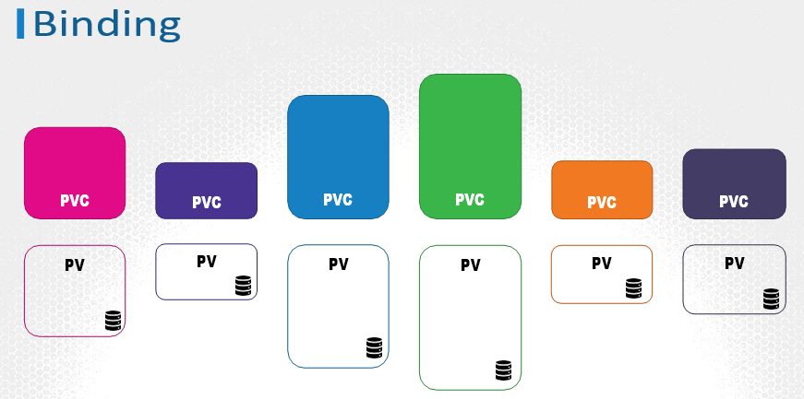

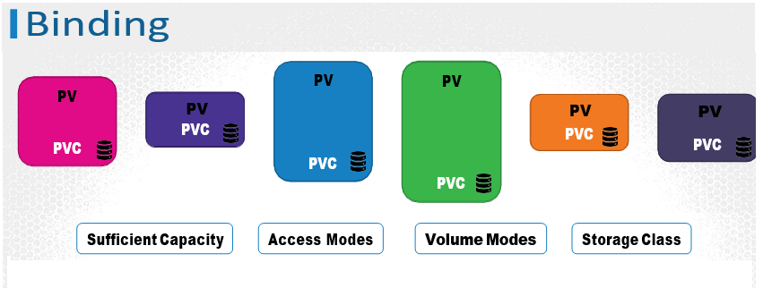

Every Persistent Volume Claim is bound to a single Persistent volume. During the binding process, kubernetes tries to find a Persistent Volume that has sufficient Capacity as requested by the Claim, and any other requested properties such as Access Modes, Volume Modes, Storage Class etc.

Finally, note that a smaller Claim may get bound to a larger volume if all the other criteria matches and there are no better options. There is a one-to-one relationship between Claims and Volumes, so no other claim can utilize the remaining capacity in the volume. If there are no volumes available the Persistent Volume Claim will remain in a pending state, until newer volumes are made available to the cluster. Once newer volumes are available the claim would automatically be bound to the newly available volume.

Let us now create a Persistent Volume Claim. We start with a blank template. Set the apiVersion to v1 and kind to PersistentVolumeClaim. We will name it myclaim. Under specification set the accessModes to ReadWriteOnce. And set resources to request a storage of 500 mega bytes. Create the claim using kubectl create command. To view the created claim run the kubectl get persistentvolumeclaim command. We see the claim in a pending state.

When the claim is created, kubernetes looks at the volume created previously. The access Modes match. The capacity requested is 500 Megabytes but the volume is configured with 1 GB of storage. Since there are no other volumes available, the PVC is bound to the PV.

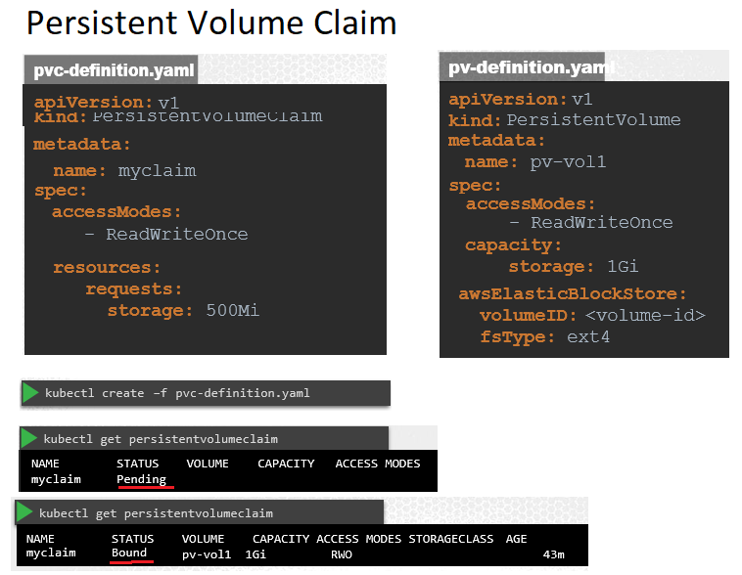

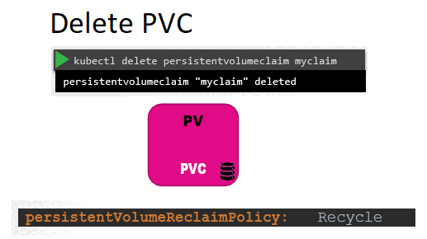

To delete a PVC run the kubectl delete persistentvolumeclaim command. But what happens to the Underlying Persistent Volume when the claim is deleted? You can choose what is to happen to the volume. By default, it is set to Retain. Meaning the Persistent Volume will remain until it is manually deleted by the administrator. It is not available for re-use by any other claims. Or it can be Deleted automatically. This way as soon as the claim is deleted, the volume will be deleted as well. Or a third option is to recycle. In this case the data in the volume will be scrubbed before making it available to other claims.

Retain

Delete

### Using PVCs in PODs

Once you create a PVC use it in a POD definition file by specifying the PVC Claim name under persistentVolumeClaim section in the volumes section like this:

1. apiVersion: v1
2. kind: Pod
3. metadata:
4. name: mypod
5. spec:
6. containers:
7. - name: myfrontend
8. image: nginx
9. volumeMounts:
10. - mountPath: "/var/www/html"
11. name: mypd
12. volumes:
13. - name: mypd
14. persistentVolumeClaim:
15. claimName: myclaim

The same is true for ReplicaSets or Deployments. Add this to the pod template section of a Deployment on ReplicaSet.

Reference URL: <https://kubernetes.io/docs/concepts/storage/persistent-volumes/#claims-as-volumes>

### Optional Topics (Not Required for CKAD)

#### Storage Classes

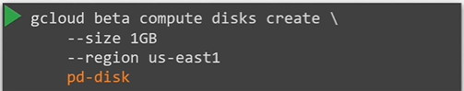

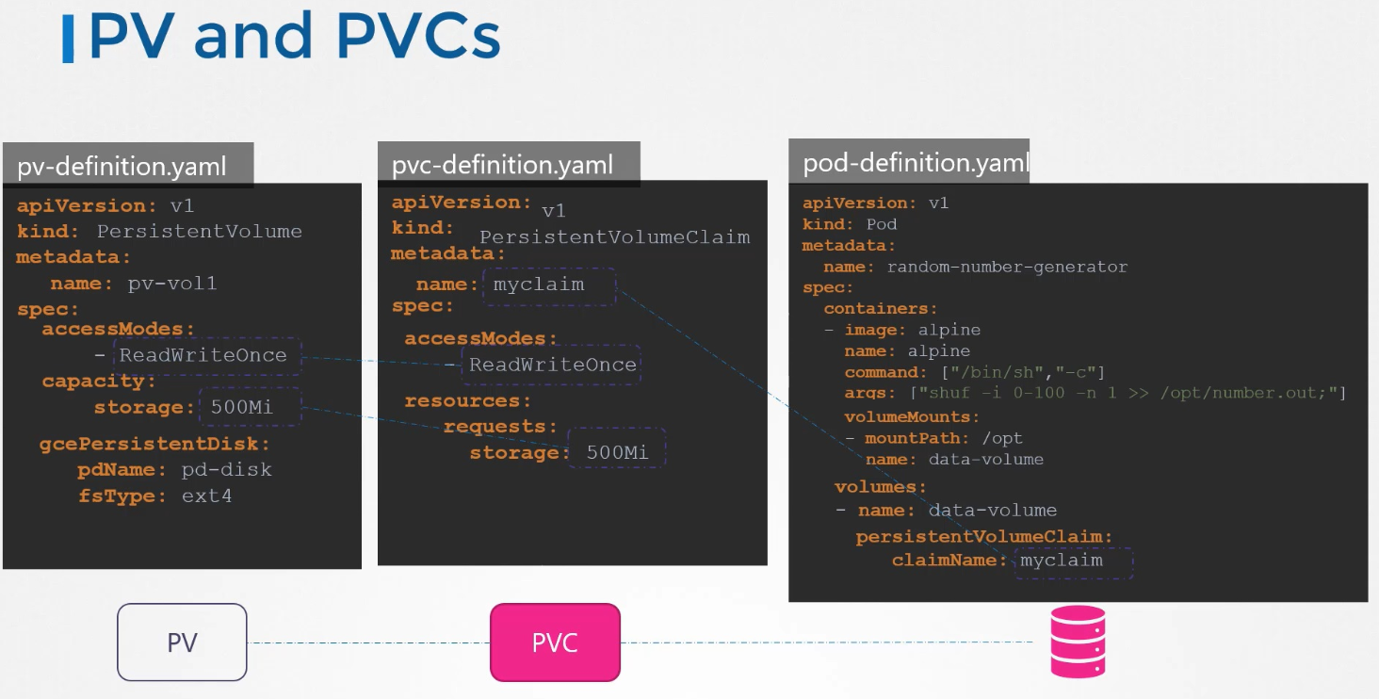

We discussed how to create PV, PVC to claim that storage and how to use the PVC as volume in pod-definition file.

Here we have created a PVC from a google cloud persistent disk. The problem with this approach is that before the PV is created we must have created the disk on google cloud.

Every time an application requires storage you have to first manually provision the disk on google cloud and then manually create a PV definition file using the same name as that of disk created in google cloud. This is called static provisioning volumes.

It would have been nice if the volumes gets provisioned automatically when the application requires it. That's why Storage Classes come in.

With storage classes you can define a provisioners such as google storage that can automatically provision storage on google cloud and attach that to PODs when a claim is made. That is called dynamic provisioning of volumes.

In dynamic provisioning, we don’t need PV definition anymore rather we need a storage class definition. The storage class automatically create the PV.

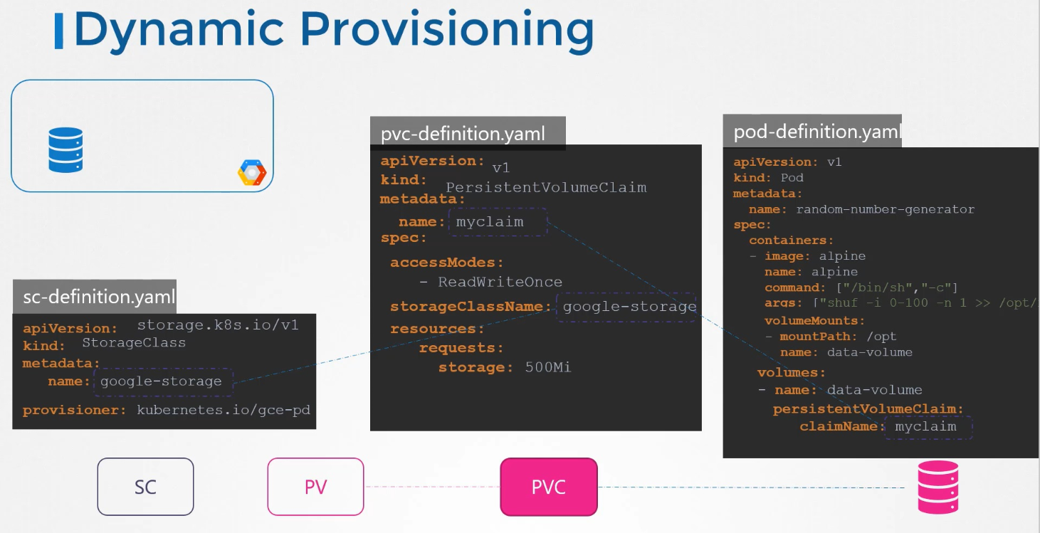

We used gce provisioner here. There are many other provisioner available.

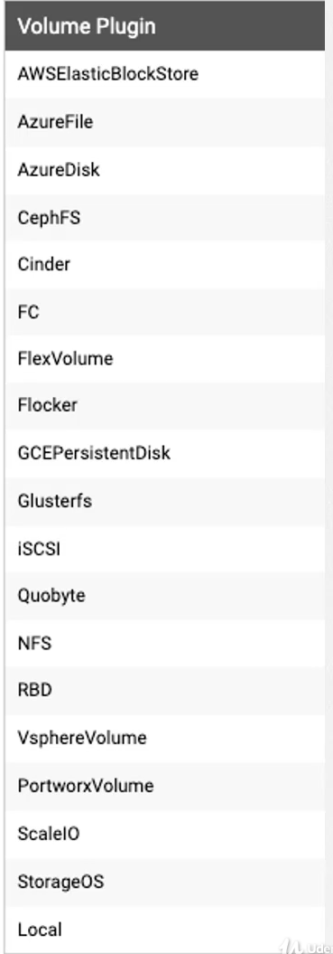

You can define storage classes with different kinds of disk.

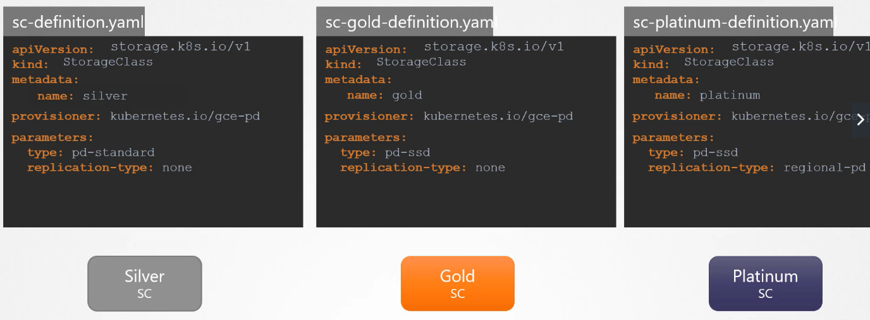

#### Stateful Sets

#### Headless Services

#### Storage in Stateful Sets